www.planninginlondon.com

Minutes of the Meeting of the Forum held at Colliers International 50 George Street W1U 7GA between 2.30-5.30pm on Monday 10th June 2013. Our host was Mark Charlton, Head of Research and Forecasting.
.

Attendance:
Brian Waters: Chairman
Andrew Rogers: Association of Consultant Architects
Brian Whiteley: LB Hillingdon
Duncan Bowie: University of Westminster
Guy Grantham: Colliers International
Jonathan Manns: Colliers International and RTPI
Judith Ryser: Isocarp/Ugb/Cityscope Europe
Martin Simmons for TCPA
Martin Taylor : Nathaniel Lichfield and Partners
Michael Coupe: London Society and Coupe Planning
Michael Bach: London Forum
Owen Wainhouse: RIBA London
Rosalie Callway: CPRE
Stuart Melrose: Colliers International
Tom Ball: London Forum
Drummond Robson: Honorary Secretary and Robson Planning

- Introductions and Apologies.
The Chairman thanked Colliers for hosting the meeting. Apologies have been received from Alastair Gaskin, David Bradley and Tim Wacher. He introduced Guy Grantham and Stuart Melrose as speakers for the first topic and Martin Taylor as speaker for the second. The third topic was introduced by Andy Rogers (who needed no introduction).

2. DISCUSSION TOPICS

First Discussion Topic
- Future Directions for Employment and B1 (Office) Space in London. Introduced by Colliers International’s Guy Grantham (Director, Research and Forecasting), with contributions by Stuart Melrose (Director, Tenant Representation).

Guy Grantham focussed most particularly on high tec. emerging office markets in which London appears to be performing well as the most successful of the major/World cities. This is because it has an enticing package to offer including a strong advertising base, financial, technical and creative talent and expertise as well as being the seat of National government and a diverse historical context.
Production and construction sectors have declined in the three decades since 1982 while services have grown.

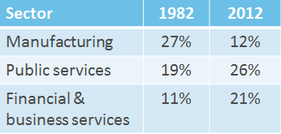
GG considered this may be attributed to generational change from a younger and definite workforce.
Colliers also identify a blend of workers ranging from Partners, employees, outsourcers, contractors, clients, employees, freelancers and contingent staffs rather than a more simple structure of the employers and employees.

The key motivators of this change appear to be what have been called generation “y”: 20-30 year olds who are highly motivated demanding and hungry, want to be at the heart of things and seeking a good work life balance. They want flexible working space and are not commuters. They include Tech businesses such as Yahoo and Google. Implicit in this is a footloose economy which is quick to adapt at a faster rate than office supply can meet it. There are no longer enough warehouse buildings left to convert for example.

Correlation to ‘Age’:
    - Generation Y (1980+) 20-30yrs old
    - Generation X (1970s) 30-40/45 yrs old
    - Baby-boomers (late ‘40s – 60s) 40/45 yrs +
Key characteristic (nature) difference to ‘older groups’:
    - ‘Hard-wired’ to modern communications technology.
    - Creating new skills, needs and (employment) orientations
Message to employers/occupiers & developers:
    - Adapt to & embrace new comms technology
    - Not just professional/technical, Social equally important

City Core Take Up: Banking Sector :
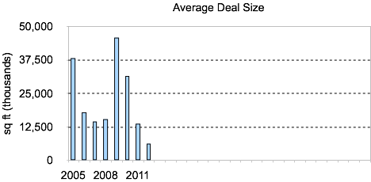

Grey, Surplus and Legacy Space:

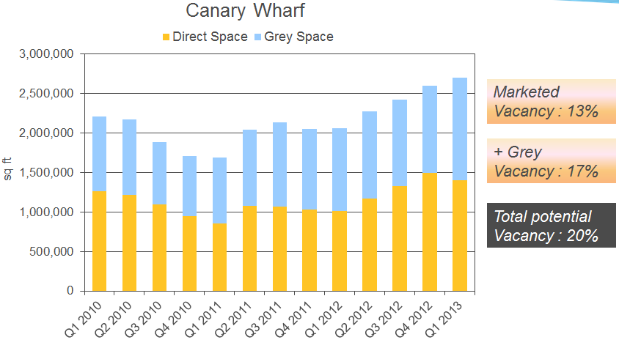

New Grade A Supply compared with Grade A Absorption 2010-2013

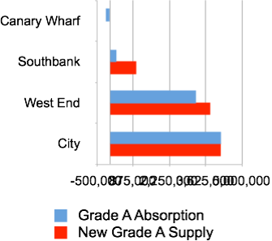

Media and Tech Growth 2009-2012:

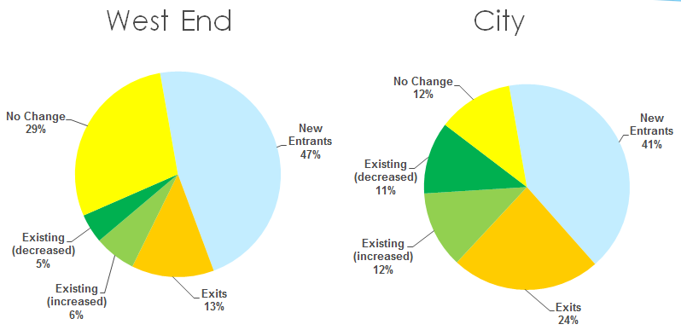

There have been dramatic changes in perception, notably by “generation “y” staffs of what constitutes tech space, going from

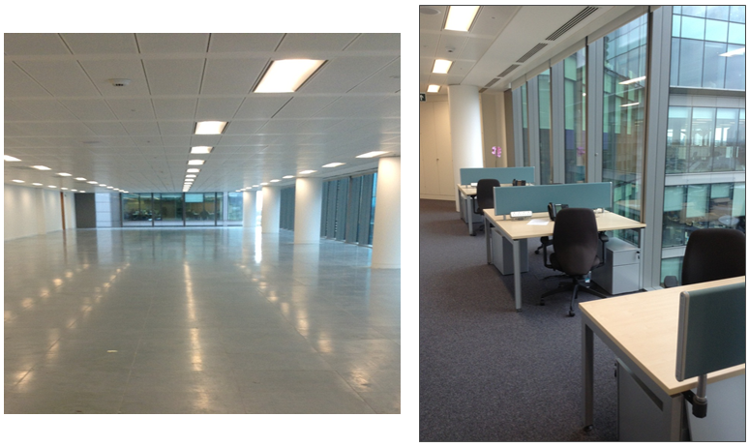

to



Google’s decision to occupy space at King’s Cross because of London’s global offer and reach symbolises this evolution of high tech office space. Its characterisrics include

- Being Future Proof
- Including Sports Hall, Auditorium, Swimming Pool
- Reconfigurable workspace
- Full Bicycle access
- Being a Destination
- At a Transport Node
- Providing ‘activity-based’ space
- and Life / work balance

In summary

    - London remains a job magnet – it’s the whole package
    - Keeping Gen Y happy!
    - Changes are happening now / real, driven by technology
    - New breed of occupiers want more control over space but will adapt
    - Footloose - Its’ all about the product
    - Sustainability
    - Significant implications for developers and owners

A summary of and extracts from Colliers Media and Technology Monitor January 2013 Follows:

https://landingpages-doc-optify.s3.amazonaws.com/QOVCA6L3/UK-media-technology-monitor.pdf
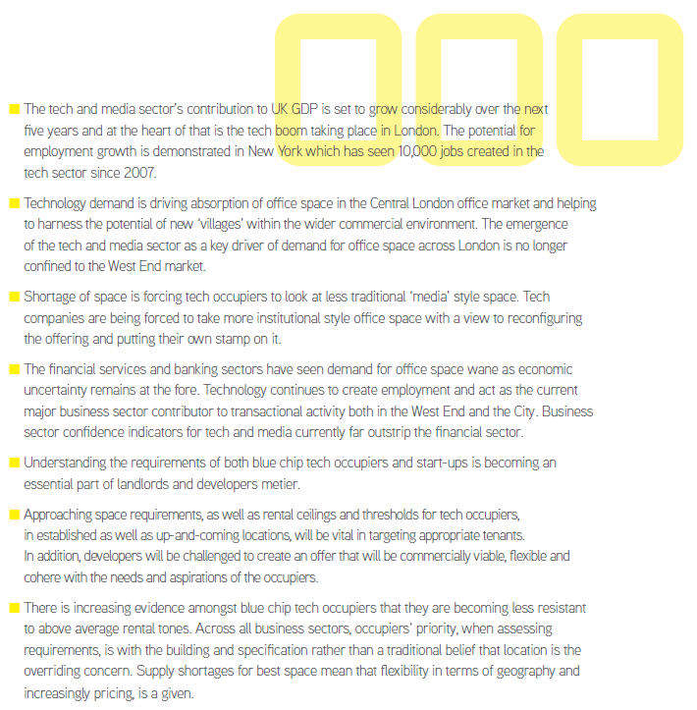



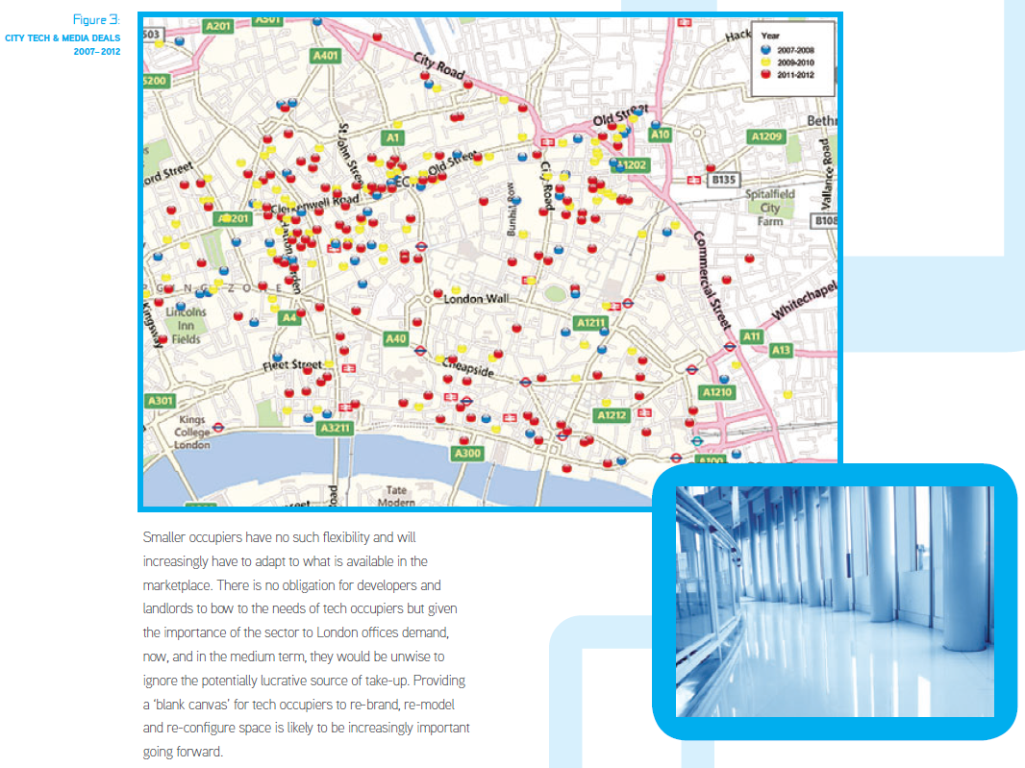
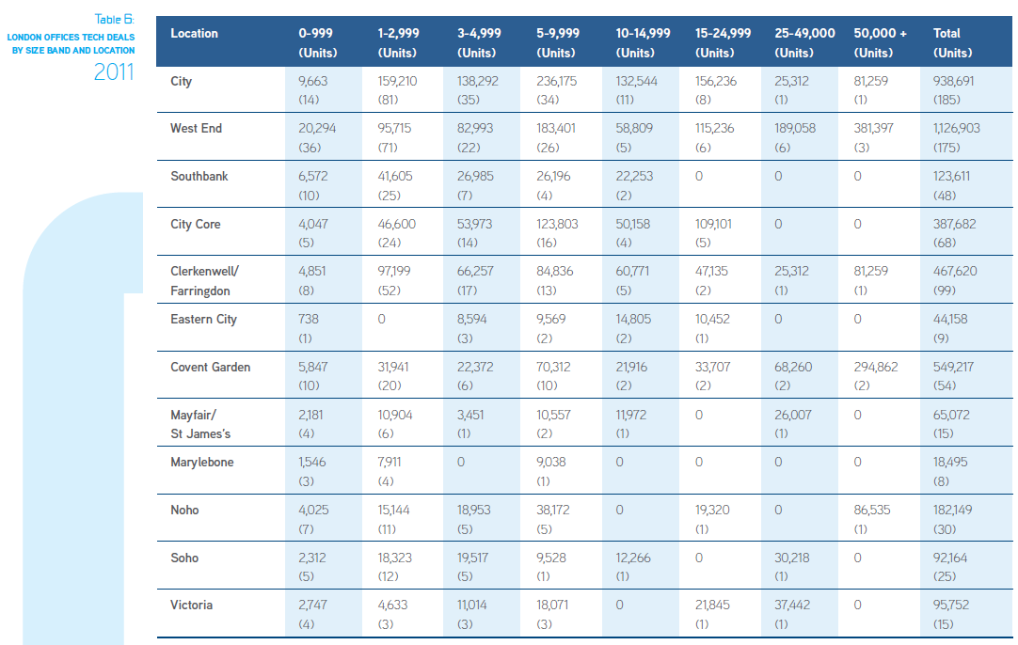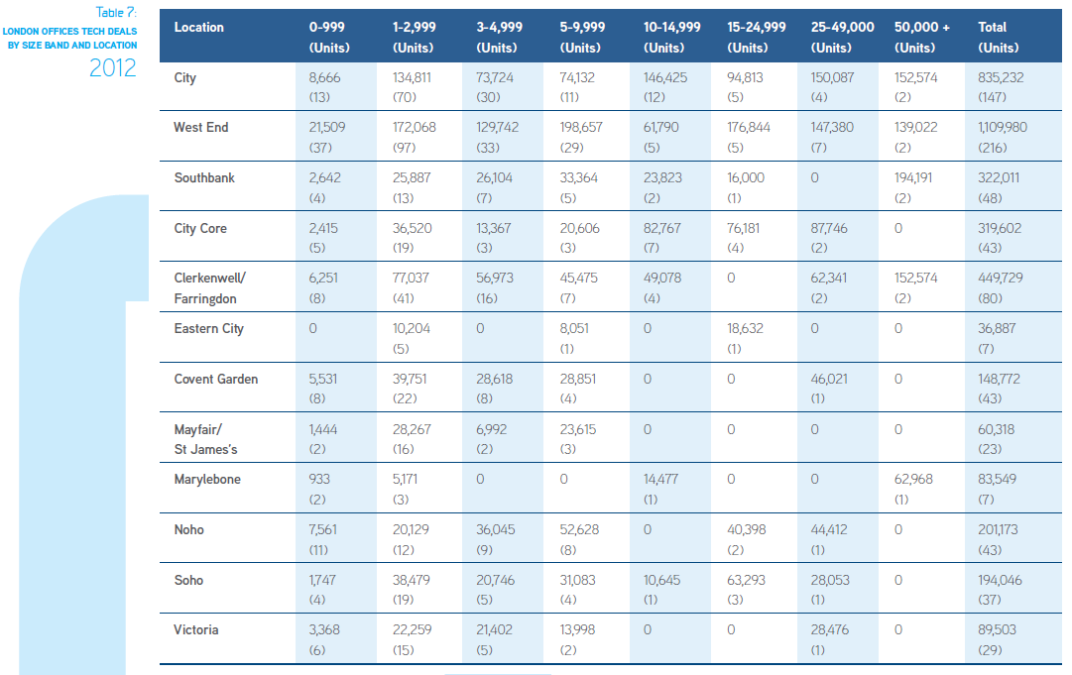

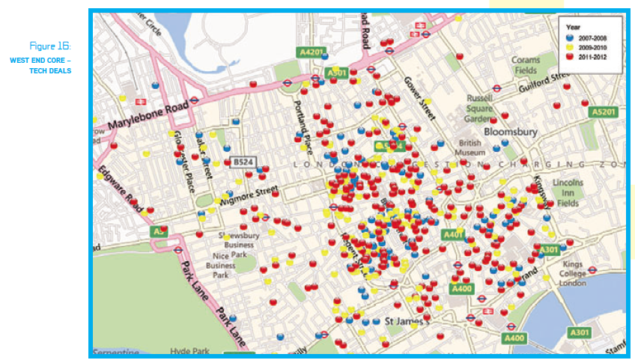

Threats to tech

Discussion:

Brian Waters opened the discussion by saying that funding is a key problem for increasing supply quickly. Guy Grantham confirmed this was why Amazon took premises in Holborn Viaduct because there was nothing available in the usual core locations. Stuart Melrose added that people are anxious to locate near Crossrail – notably in Farringdon.

Brian Whiteley wondered about the future for sites such as Stockley Park which was not on Crossrail and was assured that here vacancy rates were low at 13% and it continued to attract global corporates.
Other fashionable growth areas include social media organisations resulting in something of a two tier media market. 40 Chancery Lane and Sea Containers House are examples of this, not seeking W1 prices.

Duncan Bowie saw an irony that a previous forecast of everyone working at home has not happened. He was concerned at the growing disparity between these areas of growth and the lack of social service support.

Michael Bach wanted to explore vacancy rates and what was acceptable since Colliers figures suggested the need for a much higher vacancy rate than the 8% contained in the London Plan. He asked whether this was sufficient to justify a change of policy.

Brian Waters suggested that the UCO needed to be more flexible to accommodate more rapid change.

Guy Grantham said that vacancy rates were now largely a problem for tenants unable to offload property rather than a landlord problem.

Drummond Robson suggested that as well as the emphasis on generation y London needed to meet the employment demands of an increasingly large aging population. GG thought that these were to be found in the more traditionally recognised office areas of City and West End. As yet there is no suggestion that reverse commuting is increasing to occupy suburban space.

Mike Coupe was critical of some recent office building designs which threatened London’s World Heritage status. Jonathan Manns disagreed and said he would love to work in places such as The Walkie Talkie and that World Heritage status is less important than this.

Second Discussion Topic

- Martin Taylor of Nathaniel Lichfield and Partners was welcomed to introduce the item “NPPF a year on – planning and development progress in London and implications of latest household projections.”

- The NPPF is 15 months old
- National Planning Policy Framework was the outcome of the Governments drive to reduce thousands of pages of National Planning Policy into one document.
- Sets out the new approach to planning following the revocation of the Regional Strategies.
- All RS’ now revoked, with the exception of the London Plan, which will remain the regional planning document for Greater London.
- London Plan was published in July 2011 – pre-dating the NPPF
- The NPPF is a marked difference in approach to planning for housing growth
- PPS3 requirement is “Take into account:
  - Evidence of need and demand
  - Availability of land
  - Housing affordability
  - Sustainability
  - Infrastructure”

NPPF requirement is to
  - “ensure that their Local Plan meets the full, objectively assessed needs for market and affordable housing in the housing market area”

- Lessons to be learned from the rest of the Country?

55 local plans (as core strategies) have been examined or submitted for examination
Of these 55% submitted a plan proposing a reduction in their housing target
18 of the 55 were found to be sound
44% had to increase their submitted housing target in order to be found sound
5 plans are subject to immediate/early review of their housing target
2 plans were withdrawn on the basis of soundness concerns
2 plans were found sound with a target lower than both the regional Strategy and household projections, but both are subject to early review.

- What does it mean for the London Plan?
- London Plan – Housing targets historically based upon capacity (the PPS3 ‘balance’ of taking everything into account)
- This was, however, Pre-NPPF – next iteration will be fully tested against the NPPF… London Plan Housing SPG (Nov 2012) signposts this requirement


- What does it mean for the London Plan? (2)
The NPPF represents a change in direction – this has been underlined by Local Plan examinations across the country
  - “Plans should meet objectively assessed needs… unless:
    - any adverse impacts of doing so would significantly and demonstrably outweigh the benefits when assessed against the policies in this Framework as a whole; or
    - Specific policies in this Framework indicate development should be restricted.”
Against the NPPF the London Plan will have to identify needs and seek to develop a strategy to meet them
So, what are London’s housing needs? (It was accepted that NPPF also makes reference to demand).

- CLG 2011-based Interim Household Projections

New household projections were released by CLG on 9 April 2013.
Falling household formation reflecting trends in undersupply, increasing overcrowding, concealed households, affordability constraints and restricted mortgage finance.
Notwithstanding, the projections highlight a mis-match between London’s need and planned supply in current policy for the period 2011 to 2021:
  - Projected Household Growth in London: 52,570 per annum – up from 37,900 per annum over the same period in the previous projections
  - London Plan housing target is only 32,210 per annum, well short of this resulting in an unmet need.

- London’s unmet housing needs 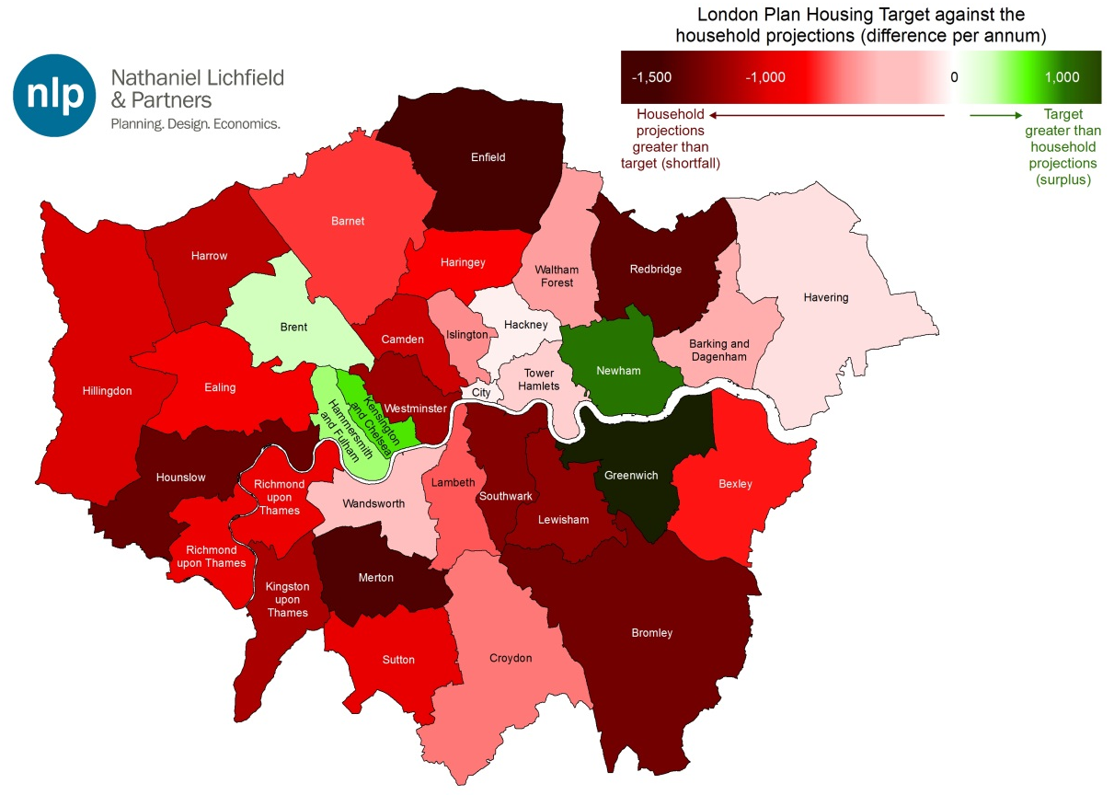
- How will the new London Plan meet ‘needs’?
Previous ‘capacity’ based approach to London Plan housing targets would not appear to conform with NPPF
‘Need’ based approach would indicate requirement to substantially increase planned housing supply in Greater London
What’s the best way forward:
  - Even higher densities within the urban areas?
  - Release of Green Belt on London fringe?
  - Home Counties take more of a share under the ‘Duty-to-Cooperate’?
  - A new wave of London Overspill New Towns?
  - OR, is ‘business as normal’ an appropriate stance for the London Plan to take?

Discussion.
Duncan Bowie thought that the housing strategy of the GLA was more sophisticated than to be found outside the Capital but nevertheless accepted there is a growing shortfall with little prospect of it being met. The SHLAA working party will need to address this issue. He advocated areas of increased density and growth in the opportunity areas. He also lamented the prospects for the social renting market which appears to have almost dried up, adding that many social landlords were pursuing market solutions only in a grant free world.
He was concerned about housing quality given the pressures for hyperdensity in Central and Inner London. He argued for Mandatory Space Standards. This was a view echoed by Tom Ball.

Ros Callway for CPRE supported the need for increased density but thought that many sites with approvals were not being developed because the housebuilders were sitting on them. She offered the statistics that 1,700 sites for 130,000 dwellings were not currently being pursued. This leaves the queries how do you unlock development and how do you get affordable housing?. Others present did not agree with this analysis.

Brian waters suggested the relaxation of s106 constraints. Sometimes a developer takes a hit on a scheme – e.g. Battersea Power Station, until someone with adequate funding is prepared to take the risk. For example Berkeley Homes will not build until 50% are presold and many of these are to people from abroad.

Tom Ball advocated the return of Council housing. At present in Westmister 80% are being sold to Non Doms adding to the pressure to convert offices to flats.

Martin Simmons could see no evidence for growth into the Home Counties and no evidence of Home County Districts taking on the responsibility for higher targets. He also thought that the mayor’s section 348 powers should be invoked but that there appears to be no political stomach for this.

Third Discussion Topic

- Permitted Development Rights introduced by Andy Rogers ACA. (See The Town and Country Planning (General Permitted Development) (Amendment) (England) Order 2013) http://www.legislation.gov.uk/uksi/2013/1101/made

The Order came into force on 30 May 2013 (but in most cases expiring 30 May 2016). In summary it:
ADDS
- Part 4 of Schedule 1, defining exemptions to office change of use.
AMENDS
- Part 1 of Schedule 2, Class A; by adding para.Al(ea) relating to larger extensions.
- Part 2 of Schedule 2, Class A, revised A. 1(a); allowing 2m high walls to schools.
- Part 3 of Schedule 2, Class B, revised B.1; allowing change of use Up to 500M2 from 235m2! SASS!) -
- Part 3 of Schedule 2, add Class 3; allowing change of use from B.1(a)(offices) to C3, subject to prior approval re transport/highways, contamination and flooding.
- Part 3 of Schedule 2, add Class K; allowing change of use from 131, C1, C2, C2A, and D2 to a state-funded school, re transport/highways, contamination and flooding.
- Part 3 of Schedule 2, add Class L; allowing reversal of any Class K change of use.
- Part 3 of Schedule 2, add Class M; allowing change of use of agricultural buildings and land in their curtilage to "a flexible use" in Al, A2, A3, 131, B8, C! and D2, up to 500m2, possibly subject to prior approval.
- Part 3 of Schedule 2, add paragraph N; setting out prior approval procedures
(10 sections). [These do not appear to relate to Parts 1 and 2, see above.]
- Part 3 of Schedule 2, add paragraph 0; providing definitions of some terms.
- Part 4 of Schedule 2, add Class C; allowing the use of any unclassified building and its curtilage as a state-funded school for a single academic year, subject to Ministerial approval.
- Part 4 of Schedule 2, add Class D; allowing a change of use from A1, A2, A3, A4, A5, B1, D1, and D2 to "a flexible use" in Al, A2, A3 or B1 for a period of up to two years, subject to five restrictions and five conditions.
- Part 4 of Schedule 2, add paragraph E; providing definitions. paragraph E;
- Parts 8, 32, 41 and 42 of Schedule 2; allowing larger buildings/extensions and making amendments in line with the above revisions, subject to various minor conditions/restrictions.
- Part 24 of Schedule 2; removing the prior approval requirement for broadband poles, cabinets and lines on article 1(5) land, until 30 May 2018.
ANDREW ROGERS

SUPPLEMENTARY NOTE: Legislation allowing larger single-storey rear extensions to be built under permitted development rules came into force on 30 May 2013. The new size limits will be subject to a neighbour consultation scheme.
An extension or addition to your house is considered to be permitted development, not requiring an application for planning permission, subject to the following limits and conditions:
- No more than half the area of land around the "original house"* would be covered by additions or other buildings.
- No extension forward of the principal elevation or side elevation fronting a highway.
- No extension to be higher than the highest part of the roof.
- Single-storey rear extension must not extend beyond the rear wall of the original house* by more than three metres if an attached house or by four metres if a detached house.
- Maximum height of a single-storey rear extension of four metres.
- Extensions of more than one storey must not extend beyond the rear wall of the original house* by more than three metres.
- Maximum eaves height of an extension within two metres of the boundary of three metres.
- Maximum eaves and ridge height of extension no higher than existing house.
- Side extensions to be single storey with maximum height of four metres and width no more than half that of the original house.
- Two-storey extensions no closer than seven metres to rear boundary.
- Roof pitch of extensions higher than one storey to match existing house.
- Materials to be similar in appearance to the existing house.
- No verandas, balconies or raised platforms.
- Upper-floor, side-facing windows to be obscure-glazed; any opening to be 1.7m above the floor.
- On designated land* no permitted development for rear extensions of more than one storey.
- On designated land no cladding of the exterior.
- On designated land no side extensions.
Discussion. The principle concern with this PD package is how it will work when the change lasts only until 2016. If it means that developments not realised within two years have to revert to the former use there will be no take up. Ron Heath and others thought the period for take up was too short.

3. Minutes of Meeting held at at GLA City Hall The Queen's Walk, London SE1 2AA, on Monday 4th March 2013 and matters arising.

These were accepted without comment.
4. Treasurer’s report.
None.
- Next Meeting
Confirmed at RIBA London, 77 Portland Place W1 on Monday 16th September 2013 at 2.30pm Discussion topics: The Mayor’s Vision for 2020. Our host is Owen Wainhouse, Policy and Communications Manager, RIBA London
(It is hoped that Sir Edward Lister for GLA may be willing to address the next meeting on the topic of the Mayor’s 2020 Vision (issued the day after the Forum meeting). If so it would be more appropriate to hold the meeting at City Hall.– please look out for any changes). Other suggested items included the new Chinese investment East of London, Matthew Taylor Planning Reforms and Hillingdon’s Townscape Study – with proposals from Allies and Morrison indicating how the suburbs could look.
6. Review of standing items.
None
7. AOB
Details of The London Planning Summit 2013 on Thursday 19th September may be found at
- http://rtpilondoncalling.wordpress.com/2013/06/07/london-planning-summit-2013/

DR/dbm 13.6.13

