www.planninginlondon.com
Minutes of the Meeting of the Forum held on Monday 7th December 2009 at RICS, 12 Great George Street, Parliament Square London SW1P 3AD between 2.30 and 5.30pm. Our host was Jo Shockley, Head of Policy and Communications.

Attendance: Brian Waters: Chairman
Andrew Rogers: ACA
Brian Whiteley: RTPI, London Borough of Newham
Duncan Bowie: London Metropolitan University
Daniel Alston: TfL
Jo Stockley: RICS
John Lett: GLA
Judith Ryser: Isocarp/Cityscope Europe/UDG
Kay Powell: National Planning Forum
Michael Bach: London Forum
Michael Coupe: London Society
Riette Oostørhuizen: Head of Planning, HTA
Ron Heath: RIBA LU&PG
Tim Wacher: RICS
Tom Ball: London Forum
Drummond Robson: Honorary Secretary and Robson Planning
Wayne Hincks: Barton Willmore/RIBA London

AGENDA
- Introductions and Apologies.
Brian Waters thanked Jo Shockley for organising the event and providing muffins. Apologies were received from Alastair Gaskin: Treasurer, Esther Kurland, Mark Loxton, and Peter Eversden.

2. Discussion Topics
1. The Consultation Draft Replacement London Plan. A presentation by GLA’s John Lett. Associated with 2. The Mayor’s Transport Strategy. An Overview by Daniel Alston - Programme Manager from TfL.

John Lett introduced the topic with some basic demographic trend statistics, demographic structure and employment trends and structure. London’s population has declined from1945 to the late 1980s when it started to increase again to the present figure of over 7.5 million. Simple GLA projections indicate a rise of 1.3 million to well over 8.75 million by 2031. It involves inward migration from abroad and the wider south east. International migration has been in successive waves including old commonwealth, new commonwealth, new EU accessions. Out migration has been of families and older people leaving a youthful London pattern with many of child bearing age. A further component is the 270,000 of 60-65 years and the very elderly – over 85. Households are projected to increase by 0.8 million and employment by 0.7million with household expenditure doubling to £160 billion.

Basic employment trends indicate a fall from 1971 when employment was above 4.5 million to about a million less in 1995 from which there has been a recovery to 1971 figures. Following a drop in the present recession the trend is again upwards from about 2012 towards 2031, although there are widening differences depending on who is doing the predictions. The predictions are always well over the top if they are treated as forecasts but the principle is to plan for growth. There is set to be substantial increase in jobs in the next 20 years to 2031 despite the current economic downturn – an extra 750,000 jobs, a 17% increase – 35% of which will be in the CAZ and Canary Wharf.

Relative deprivation seems to be little different from the pattern of persistent poverty identified by Charles Booth in the late 1880s.

More Strategic. The draft replacement London Plan is shorter and intended to be more strategic.
New Plan 282 pages (2008 Plan 494), 122 policies (2008 Plan: 206)
Policy content is split functionally for clarity between:
  - Strategic
  - Planning decisions
  - LDF preparation
It is also more user-friendly, and arranged as:
1: Context and strategy (Mayor’s vision and objectives)
2: Places (with a stronger spatial vision)
3: People(housing and social infrastructure)
4: Economy
5: Response to climate change (& resource management)
6: Transport
7: Living places and spaces (built/natural environment /waterways)
8: Implementation
Initial consultation with the London Assembly and the GLA Functional Bodies ended 30 June 2009. Now issuing draft replacement Plan for public consultation for a three month consultation period: 12 October 09- 12 January 2010. Economic Development and Transport strategies have been produced to a common timescale and evidence base. This first step towards integration was welcomed by the Forum.

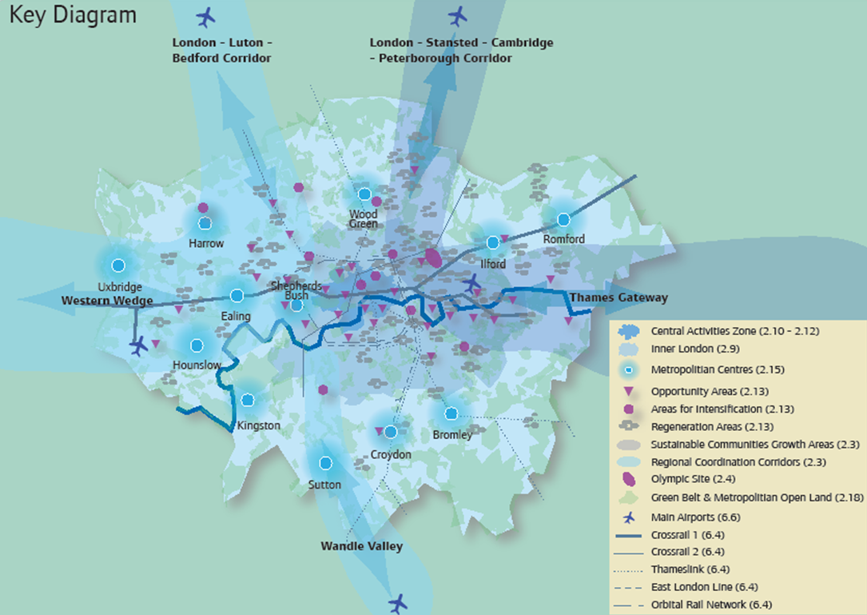

Challenges are
- A growing – and changing – population
- More households
- A growing – and changing- economy
- Persistent poverty and disadvantage
- A changing climate
- Ensuring the infrastructure London needs
- Securing the legacy of 2012
- A new focus on quality of life
- A changing planning system

Statistically, these challenges could mean that to 2031: population grows by 1.3 million, households by 0.8 million, and employment by 0.7 million, with household expenditure almost doubling to £160 billion. Also perhaps there will be 4 million more trips per day by 2023 and a consequential 15% increase in CO2 output if we do nothing to address it.

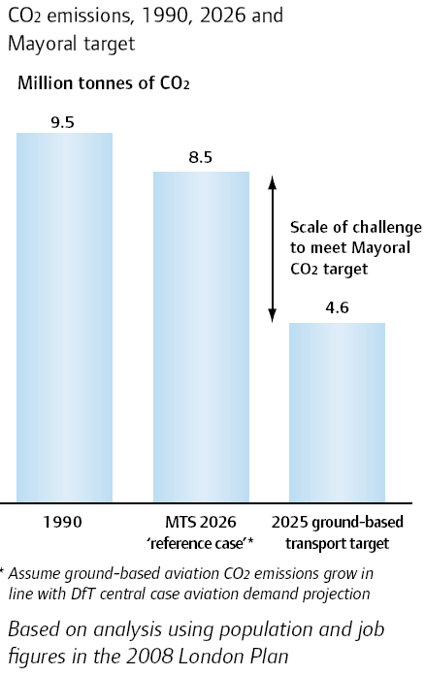

There may be a need for:
- 40,000 more hotel rooms, 1.3 – 2.2 million sq m of comparison goods floorspace, 2.25 sq m of office space in central London alone, and 33,000 more homes p.a. across London

Highlights of the replacement Plan:
The Strategy Vision is that over the years to 2031 – and beyond, London should excel among world cities – expanding opportunities for all its people and enterprises, achieving the highest environmental standards and quality of life and leading the world in its approach to tackling the urban challenges of the 21st century, particularly that of climate change.

The strategy is supported by 6 detailed objectives:
A city that meets the challenges of economic and population growth
An internationally competitive and successful city
A city of diverse, strong, secure and accessible neighbourhoods
A city that delights the senses
A city that becomes a world leader in improving the environment
A city where it is easy, safe and convenient for everyone to access jobs, opportunities and facilities

Sub-regions
The new sub-regions are
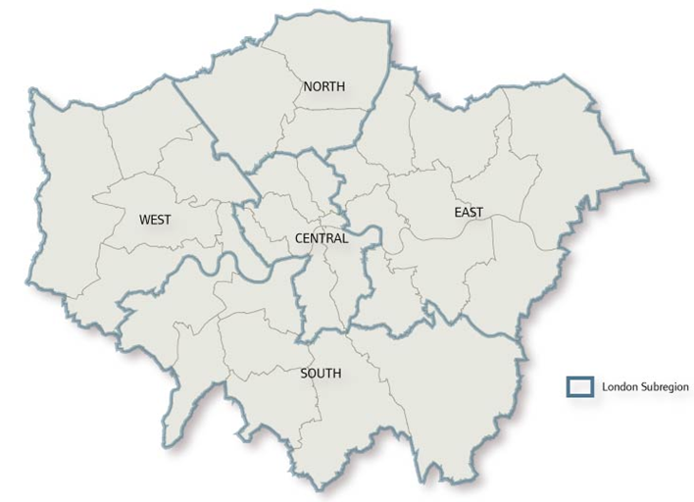

Strangely the sub regions differ from the definitions of Central, Inner and Outer London.

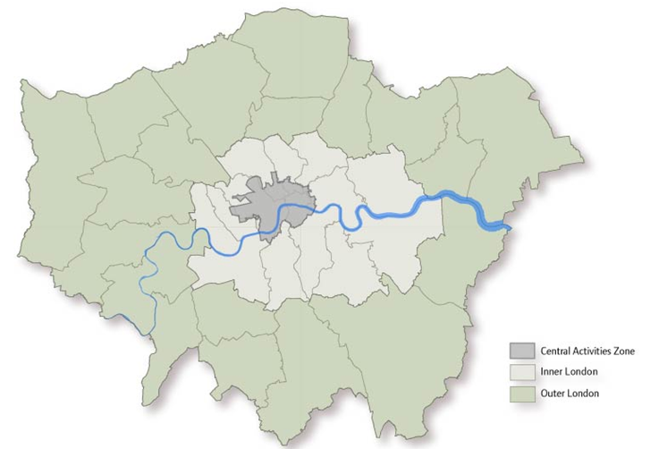
It is intended that planning be less prescriptive, with greater focus on Outer London and the importance of town centres to provide a vision and strategy, with emphasis on the economy, transport and a new strategic development centre concept.
The distinctive policy approach to inner London is to sustain growth, tackle deprivation, improve the environment
In Central London a more nuanced approach to CAZ is planned to provide a rich mix of local as well as strategic uses and forming London’s globally iconic core, concentration on its strategic functions, with more local and residentially-based activities

Opportunity and intensification areas:
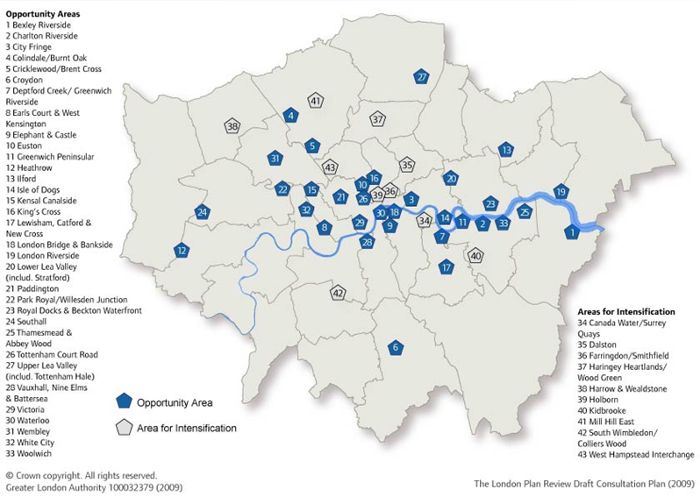

The plan retains the framework of 33 Opportunity Areas, including 4 new ones (Charlton, Earl’s Court, Kensal Canalside, Southall), 9 Areas for Intensification including 2 new ones (Dalston, Harrow & Wealdstone). Arsenal is now seen as complete.
Regeneration Areas (but on Super Output Area basis)???

Town Centres are seen as a key spatial priority with the main focus beyond CAZ for development
support for partnership approaches, strategic guidance on policy directions. Shepherd’s Bush and Uxbridge have been added as new Metropolitan centres, and Canary Wharf as a major centre. Interestingly Brent Cross/Cricklewood is not identified as having town centre status, but rather an area for intensification (see Key Diagram).

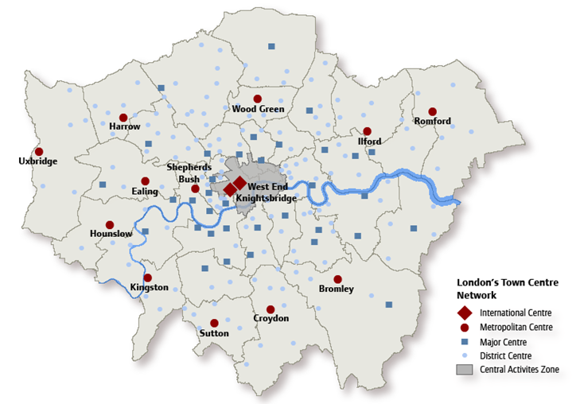

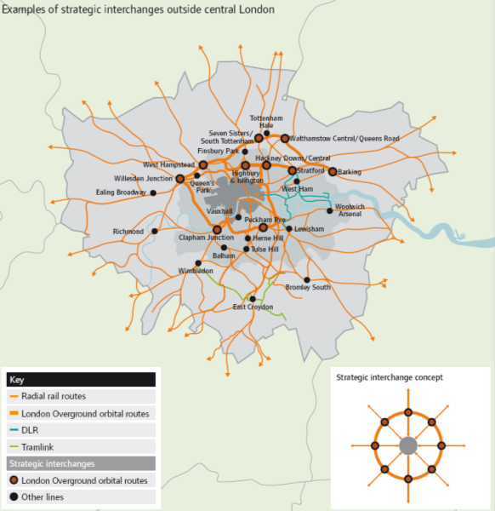

The pattern of strategic interchanges (figure 44) is not yet related to that of the town centre hierarchy.
Industry:
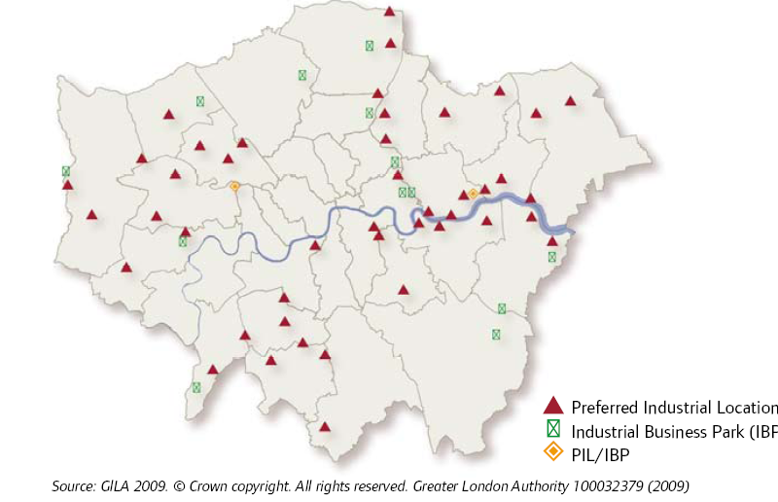

Key emphases are: Recognition of the different roles of industrial capacity, Stronger support for effective implementation of industrial policy, Managed release of surplus, especially in east.
Clearer recognition of need for protection elsewhere. Areas for regeneration should include finer grained recognition of deprived communities – in Outer as well as Inner London, stronger emphasis on integrated working to address deprivation through local area agreements, MAA, LSPs, CS

Places: open spaces, strategic network of open spaces reflect the present pattern but with the intention to extend “green grid” principles Londonwide

People 1.
New SHLAA/HCS based housing targets are for 33,380 pa. additional homes on average 2011-21, to “optimise” rather than “maximise” density and provide more emphasis on housing quality
Support justified local presumptions against back-garden loss. There will be a new SPG for Space and other standards for all tenures.

Also there will be a new approach to affordable housing following the PPS3 definition but with a new £71,400 upper threshold for larger Intermediate homes and the percentage-based target, is proposed to be replaced with 13,200 pa. Borough contributions are to be agreed, maximising on development proposals with a 10 unit threshold – or less.

People 2
More emphasis on housing choice, All provision to Lifetime Homes standard, 10% wheelchair
Support for private rent. Students accommodation should not compromise conventional capacity; affordable housing applies unless s106 secures it to universities.
300k more older people – affordable housing principles to should apply to class C2 uses.

Gypsies and travellers: 538 pitches 2007 – 2017: borough targets, plus 40 transit and 73 show people pitches distributed sub regionally.
More balanced mix of tenures, especially in neighbourhoods where social renting predominates.
Existing stock: condition; retrofitting; short term lettings; estate renewal; special needs; vacants
The plan also proposes stronger support for social infrastructure, especially health, education and sports

Economy 1
- Support for a more diverse economy
- Greater recognition of SMEs
- Offices: distinctive approaches in different areas: 2.25 million sq m in CAZ/IOD, but elsewhere temper benchmarks with other indicators. Swaps/Credits
- More rigorous approach to release of industrial land: SPG now reflected more strongly in in policy
A plan identifies borough groupings for transfer of industrial land

Economy 2
- Visitors: 40,000 room target – 10% wheelchair accessible; Retail: strong town centres first (in/edge of); pro-active working to identify capacity; importance of ‘walk to services in Neighbourhoods/District centres’; small shops
- New & emerging sectors: strong emphasis on innovation; HE/FE needs; ICT infrastructure
- Opportunities for all: more closely integrated with Economic Development and Skills Strategies

Response to Climate Change
- Mitigation:
Sets 60% emissions reduction target and targets for emission reductions in new development
Sustainable design and construction principles. Stronger emphasis on retrofitting including synergies with new and existing development 25% heat & power from renewable/decentralised energy by 2025: set objectives, more flexibility about means. Support for innovative technologies
- Adaptation:
Stronger, target-based approach: Over-heating/cooling; urban greening/green roofs, Flood risk management; sustainable drainage; water quality & sewerage, Heat density in London

Waste
More emphasis on self-sufficiency especially through…
recycling/composting municipal waste: from 21% 2008 to 60% 2030, and
recycling/reuse of construction waste from 82% 2008 to exceed 95% by 2020
hazardous waste management requirements likely to increase
increased waste processing capacity within London: update arisings projections and borough apportionments using 2007 methodology

Aggregates, contaminated land & hazardous substances:
Aggregates: importance of recycling plus 1 million tonnes of land won aggregates from within London
Contaminated to brownfield development capacity
HSE PADHI methodology: balance risks, benefits and existing development.

Transport 1
Close integration with Transport Strategy to:
Encourage patterns of development that reduce the need to travel, especially by car
- Improve capacity for public transport, cycling, walking, especially in areas of greatest demand
- High trip generating development only at places with good existing or planned public
transport
- Improve interchanges/public transport connectivity
- Increase use of Blue Ribbon Network
- Enhance logistics system efficiency/minimise impacts
- Encourage shifts to sustainable modes
- Promote greater use of low carbon technologies
- Enhance attractiveness of walking

A plan for radial cycle super highways has been prepared.

Transport 2
- Transport Assessments including cumulative impact: BPG
- Strategic support for Crossrail tariff and similar approaches elsewhere (eg Northern Line
Extension)
- Firm opposition to third runway at Heathrow
- Increase public transport capacity: revised schedule of funded and unfunded investment proposals
Major transport schemes include Crossrail 1, Crosrail 2 (Chelsea Hackney), Thameslink and Orbital Overground.

Transport 3
- Smooth traffic flow, tackle congestion
- Support for limited improvements to the road network
- Development/parking balance: appropriate balance between promoting new development and preventing excessive parking which undermines wider objectives
- Town centre parking: more flexible approach in those in need of regeneration
- Outer London office parking: criteria for more flexible approach
- Freight: London by-pass corridors; freight location criteria; consolidation & ‘break bulk’ facilities; safeguard aggregate railheads; criteria based support for strategic rail freight interchanges

Living Places and Spaces
- Support for place-shaping, neighbourhoods and communities: inclusive environment; secured by design
- More emphasis on local context and character in architecture/public realm policies, including heritage environment and landscapes
- Strategic approach to identifying suitable locations for tall buildings: urban design analysis, LVMF
- Safety, security, resilience, air quality, noise pollution
- Emphasis on protection/promotion/enhancement of green and open spaces and waterways: bio-diversity, woodlands, geology, land for food, Blue Ribbon Network

Blue ribbon network
Implementation
- Pan-London approach to replace sub-regional implementation frameworks
- Outlines plan-monitor-manage approach
- Implementation Plan to be published later
- Looks forward to Community Infrastructure Levy

Next Steps
- October 2009-January 2010: public consultation

Engagement events
- July/September 2010: examination in public
- Winter 2011/12: Replacement Plan published

Daniel Alston’s presentation of the Mayor’s Transport Strategy followed.

Mayor’s Transport Strategy
TfL Strategy and Policy
Shaping London
Current travel demand in London
Some numbers: travellers into London every day (2007) 2.2m tube/DLR, 2.1m rail, 3.3m bus and tram, 9.6m cars, 5.7m walking trips, 0.9m other modes. Total trips per day 24m. TfL runs or specifies services for 8,000 buses, 500 tubes trains, 24 trams, 54 trains (Overground), 100 DLR vehicles, around 70,00 licensed taxis and private hire vehicles, 6000 traffic signals, 500Km streets

Distribution of population growth by 2031
Distribution of employment growth by 2031
Mayor’s Transport Strategy Goals are
- Support economic development and population growth
- Enhance the quality of life for all Londoners
- Improve the safety and security of all Londoners
- Improve transport opportunities for all Londoners
- Reduce transport’s contribution to climate change, and improve its resilience
- Support delivery of the London 2012 Olympic and Paralympic Games and its legacy
Committed Business Plan investments to 2017/8 – overview
Committed “TfL” investment
Tube upgrade = 30% increase in capacity by 2020
Crossrail = 10% increase in overall capacity in London’s rail network
- The TfL Business Plan sets out how we will improve and expand London's transport network up to 2017/18
- 40% of TfL’s investment programme will be financed though the £39.2bn 10-year funding settlement from Government covering the period to 2017/18
- This, combined with fare revenue and other third-party income, will allow TfL significantly to increase the capacity and reliability of the network across London
- Key Risk = performance of the economy and its impact on TfL income
- This Plan takes account of the hugely significant changes that have occurred over the past year, in particular the economic downturn and the cost legacy left by Metronet’s failure.
- It also provides additional funding to a number of Mayoral priorities, such as Cycle Superhighways and urban realm projects.
- The Plan is financially balanced in that income from fares and charges, together with Government grant, secondary income and borrowing, fully meet the cost of operations and the Investment Programme, including funding Crossrail and support for the Tube line upgrades
- The settlement with the Government was very tight, and difficult choices had to be made in the previous Business Plan. These included some £2.4bn of efficiency savings resulting from an operating cost review, and cancelling development work on a number of unfunded projects. Since then, to counteract the subsequent financial deterioration, TfL’s savings programme has more than doubled in scope and ambition.
TfL’s Business Plan is financed from six main sources:
1. Income from fares and the Congestion Charging scheme
2. Government grant (TfL has a settlement with Government to 2017/18, resulting from the 2007 Comprehensive Spending Review)
3. Prudential borrowing (the amount and profile of which also forms part of TfL’s settlement with Government)
4. Secondary income, such as advertising, property rentals and interest earned on cash held on deposit
5. Third-party funding for specific projects
6. Sales of property and other assets

Committed National Rail investments to 2014 - overview
National Rail Investments = will contribute to over 30% increase in AM peak pt capacity by 2031
High Level Output Specification (as determined by Rail White Paper)
HLOS 1 takes us from 2009-2014; MTS will inform the London ‘bid’ for HLOS2 funding for 2014-2019.
There are shortfalls between committed investments and future requirements which are likely to result in continued underground and highway congestion as well as CO₂ challenges.

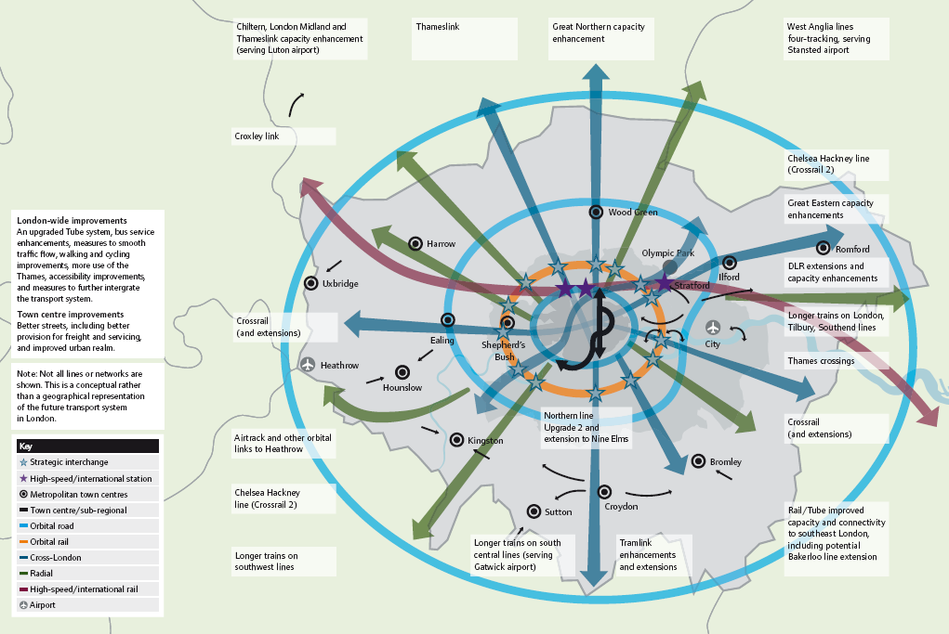

This figure sets out funded and unfunded improvements featured in the strategy

3 key aspects to MTS policies
Enhancements to London’s transport infrastructure
Orbital connectivity: strategic interchanges
Considering the needs of outer London
International connectivity
- Improved connections to London’s airports eg Airtrack
- Maximising impact of HS1 (e.g. Stratford International Station)
- Support for HS2 and terminal location at Euston
Initiatives should assist Regeneration and accessibility and the Integration of development and transport
Local and strategic development control processes should seek to ensure a number of conditions are satisfied, including:
High trip generating developments to be located in areas of high public transport accessibility, connectivity and capacity
The design and layout of sites maximise access on foot, cycle and to public transport facilities
Maximum opportunities for sustainable freight distribution where possible
Land for transport use is safeguarded in line with London Plan policy and Supplementary Planning Guidance
Planning contributions are sought for transport improvements, where appropriate
Improved information for passengers
Other ambitions include Better streets, walking and cycling Practical Steps
Cleaner air Safety and Security Further proposals to improve walking and cycling and smarter travel measures will help to reduce the mode share of the private vehicle from 43% to 37%. Coupled with investment in public transport and measures to smooth traffic, such as better management of the road network, will help contain the increase in congestion to 14%

Discussion
The Chairman congratulated the two presenters on very full and detailed presentations. He queried why the plan appeared to ignore aviation – whether Heathrow expansion of the Gateway proposals.
In reply it was explained that more work was needed on both.

Drummond Robson queried the relationship between the patterns of strategic interchange and the town centre hierarchy. He also asked about the steps to relate London to the surrounding Districts. JL replied saying that work was progressing to improve reverse commuting, and there was scope for greater interrelationships between London and its neighbours, such as between London and the Luton/Bedford corridor and the interregional connections shown in the diagram above. Linkages were greater in West and East London arising from SEEDA and the two Development Corporations.

Michael Bach referred to the SERPLAN model and its associated rationale which should be revisited.

Tim Wacher referred to the hub and spoke system. He also queried why there was no “Plan B” in the event that some of the more ambitions future proposals such as Crossrail 2 (Chelsea Hackney) did not happen. It seems that cross river plans in East London may have been lost site of.

Michael Bach was concerned that reducing the need to travel and PPG13 principles were not in the plan. Also he queried the proposed seeming “free for all” in car parking standards, rather than focusing development on areas of public transport, linked to PTALs. It was explained that one of the limitations on development in Outer London is the demand for parking. The way the policy is recrafted is to offer flexibility rather than a free for all. The aim is sustainable residential quality with smart travel, longer trips on public transport and teleworking for example increasing the scope for growth to a greater extent than was previously thought.

Jo Shockley said it was useful to hear planning and transport together. The area of London with the least good transport capacity – east – is also the area of highest deprivation as well as the area of highest population and employment growth. Tim Wacher added that the majority of the MTS “figure 44” initiatives are in the west, not east.

Daniel Alston responded by saying that much of the work associated with the Olympics should make a big difference in the east. The Thames Gateway Bridge still reflects the need for a River Crossing which continues to be explored.

Duncan Bowie was concerned about congestion and its relationship to the residential density matrix, reinforcing the point that had been made about adding to the areas of greatest congestion. The challenges of the highway network are difficult to address without car restraint.
In reply it was asked whether if you restrain the car would public transport take up the slack? Is 50% overcrowding acceptable? The planned west to east shift of jobs has not happened. Rather one should generate the jobs in the areas for which they are suited.

Ron Heath asked whether Crossrail was likely to be too late in the plan. Also have superdensities been considered? The average build was 147 dwellings/hectare. Superdensities envisage 1500. HTA, PRP, Levitt Bernstein and Pollard Thomas Edwards looked at the criteria which would make high densities acceptable. http://www.designforhomes.org/pdfs/Superdensity.pdf It was claimed that above 435 dwellings/ha. schemes are difficult to justify. Schemes are drivn by housing demand, the appropriate density range.

RICS invited Transport Development Areas (TDAs) – to be revisited since these should be with densities set at a reasonable level sufficient to improve modal shift.

Tom Ball was concerned that the Quality of Life was not being considered adequately, in particular the way in which the emphasis on housing density detracts from planning for people and their wider needs for schools, and other associated services. In the case of transport a simple example is that there are now fewer seats than there used to be, which will continue with the proposals for Crossrail.

Judith Ryser was concerned that there is no plan B to enable a range of alternatives to be looked at. This was countered as something the process did not allow for, although different scenarios of growth had been looked at.

Brian Whiteley queried how infrastructure delivery was being considered: pipes, wires, regional flows, waste planning assumptions. Much of the concern is about who pays.

- Discussion Topic 2. “Fit for Purpose Spatial Planning”. Kay Powell, National Planning Forum.
Kay Powell congratulated Brian Waters on being elected a Vice Chairman (Professions) of the National Planning Forum. She also explained that her role as Secretary would shortly be taken over by Mike Hayes.

She introduced Fit for Purpose Spatial Planning, October 2009 (see
http://www.natplanforum.org.uk/NPF%20Fit%20for%20purpose%20spatial%20planning.pdf).

This provides a (daunting) catalogue of material which planning is expected to encompass to support economic recovery, development and infrastructure delivery; environmental management and protection; and tackle climate change adaptation and mitigation.

- Minutes of Meeting held on Monday 14th September 2009 at Greater London Authority, City Hall, The Queen’s Walk, More London, SE1 2AA, and matters arising. These were agreed.
- Treasurer’s report. There is currently £322.81 in the account. This includes one of the four payments he said he was expecting. Unfortunately, this came via BACS with no reference, so at the moment I don't know who paid it! With this amount, the LPDF account can pay for the PiL website until February next year.

- Next Meeting. It was agreed that the next meeting of the Forum would be at the Government office for London on Monday 15th March 2010.
- Review of standing items. None.
- AOB . Michael Edwards is hosting a half day conference at UCL on 3rd February 2010 supported by ACA. Details to be confirmed. This will consider what are popularly being called “Parker Boris” Standards.

