www.planninginlondon.com

Minutes of the Meeting of the Forum held on Thursday 5th March 2009 between 2.30 and 5.30pm at the Government Office for London, Riverwalk House, SW1P 4RR. Our host was Chris Poulton

Attendance:
Brian Waters: Chairman
Andy Rogers: Association of Consultant Architects
Brian Salmon: The Berkeley Group PLC
Chris Poulton: GOL
Duncan Bowie: London Metropolitan University
John Lett: GLA
Michael Bach: London Forum
Michael Coupe: Coupe Planning
Michael Edwards: UCL
Patrick Sullivan: HTA Architects
Peter Eversden: London Forum
Richard Lee: Just Space Planning Network
Tim Wacher: RICS
Tony Wilson: Planning Aid for London
Drummond Robson: Honorary Secretary and Robson Planning

Introductions and Apologies.
Chris Poulton was introduced and welcomed as the new GOL representative following Roger Chapman.
Michael Edwards advised the Forum of the death at 93 of Bartlett’s Professor Nathaniel Lichfield. His wife Dalia has attended a number of Forum meetings. The Forum expressed their condolences to her and the family. Michael explained there was to be a remembrance service which he would provide details of.
Apologies were received from Andrew Barry Pursell who was intending to talk about Crossrail development opportunity sites but had another engagement at short notice. It was agreed to postpone this discussion topic. Other apologies were from Alastair Gaskin, Bob Dolata, Brian Whiteley, Gideon Amos, Giles Dolphin, Graham Saunders, Judith Ryser, Kay Powell, Lee Mallett, and Michael Chang and Ron Heath.
Discussion Topic
Outer London Commission
The Forum welcomed John Lett from GLA’s London Plan Team for a second time in succession to present the mayor’s proposals for an Outer London Commission. Peter Eversden who has been appointed a commissioner also spoke on the later parts of the presentation.
Most of the slides are available at http://www.london.gov.uk/mayor/planning/olc/
as is Outer London Commission meeting 1 item 8 paper which supplements the presentation, together with terms of reference and membership details as well as Amer Hermis’ open letter to Will McKee, the Commission Chairman. The material draws heavily on existing London Plan information.

John Lett emphasised that the proposals start with the London Plan 2008. The definition of Outer London is principally governed by Borough boundaries although Haringey’s position is part inner, part outer, Newham is considered and only part of Greenwich is covered. The boundaries should therefore be viewed as “fuzzy”. He also referred to the relationship with the City Region.
The key Population and employment indicators show
- Outer London has 60% of London’s population, 40% of its employment
- 60% of its residents work there & a third commute to inner/central London
BUT
- In London as a whole employment grew by 6% 1989 – 2001 and by 3% 2001 – 2007 (and Inner London outside the centre by 14% 1989 – 2001)
WHILE
- Outer London grew by only 1% 1989 - 2001 and by 2% 2001 - 2007 (and adjacent counties grew by 11% 1989 – 2001)

He queried however whether this should or could be changed or whether this is this just ‘in the natural order of things’ for a big city region?

Variations across outer boroughs over past two economic cycles show
• Sharp growth in Hillingdon, Richmond, Barnet
• Declines in Barking, Waltham Forest, Croydon, Hounslow
• Outer London growth weaker overall than Inner London and areas surrounding London

Geographical variations include
- Heathrow has almost all transport, freight and storage jobs
- Outer urban areas: larger proportions in local activities, schools, hospitals
- Greatest shares of financial jobs in Croydon and SE
- Manufacturing most important to Thames Gateway
- Wholesale to Western Wedge

JL advised that it would be difficult to provide broad brush solutions to Outer London issues.
He asked whether Outer London’s employment structure was inevitably local. He noted that much employment is being lost to the Outer Metropolitan Area, remarking on the dominance of the Western Wedge growth corridor. [Although growth to the north on the A1 corridor is also of significance DR].
Employment in outer London is projected to increase by 11% overall (2006 – 2026) compared to central (26%) and inner (27%).

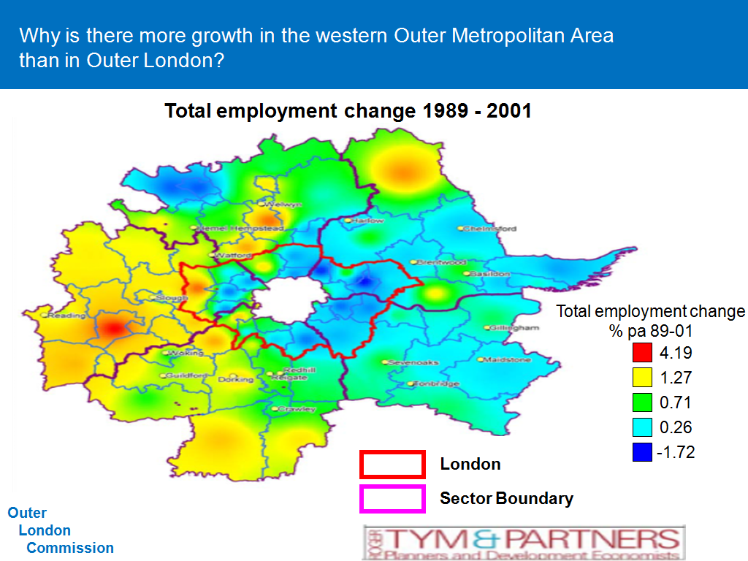

The 2001 LATS household survey of movement shows the importance of short local trips in Outer London. Also (as the caption below shows) The Majority of Outer London Workers also live in Outer London.

JL posed the question How does population change bear on economic growth?
eg 230 local jobs per 1000 popultation and what are the trends?

O.L. projected population 2006 – 2026 Thousands
2006 2026 projected % changes
Outer London 4,508.0 4,803.6 6.6
Inner London 2,953.4 3,461.6 17.2
London 7,461.4 8,265.2 10
This too conceals population decline in e.g. Harrow (0.5%) and growth in e.g Barnet (17.5%).
There are wide variations in conventional housing completions over sectors and time (1989-2007), as well as divergences from the Inner London pattern.
There are implications for the Outer London economy from an older population but these need to be considered.
Newham and Barking have highest shares of households with incomes under £15k – both around 25%.
Richmond, Kingston and Bromley with highest shares of households collecting over £60k at 26%, 20% and 18% respectively.
Shopping floor space needs have been assessed by Experian in 2004 [This looks highly questionable. DR]
It was queried whether skills and training a barrier to realising outer London potential although the census evidence suggests higher GCSE attainment levels by Outer London residents than Inner.
Turning to policy implications the presumption is that the town centres should be the locations with highest business potential, with the highest in the hierarchy being the preferred targets. This said there are wide areas of brownfield opportunity sites, notably in West London, Thamesside and Lea Valley. [No mention was made of retail parks].
More difficult is the role that should be played by London’s preferred Industrial sites and business parks.
The London Plan key diagram assumes corridor growth but it was questioned whether this is the appropriate model for Outer London.
JL suggested the objectives for growth-hubs would be to help lift Outer London economic growth above its long term trend by (for example) providing:
- competitive advantage for clusters of activities on a scale of greater than sub regional significance e.g. office, health, culture, retail,
- unique opportunities to address barriers to growth which have hitherto constrained Outer London in making a greater contribution to the London economy
- development capacity to support this scale of economic activity
- accessibility beyond the sub-regional, based on multi-modal hubs with enhanced local as well as wider connections
- a sense of place/destination of a quality of greater than sub-regional distinction
- viable justification including densification for any necessary strategic infrastructure and other investment
- strategic residential capacity to help underpin this investment, to lend vitality and viability to the hub and to help meet other housing objectives,
AND
- which will complement other business locations and their distinct ‘offers’ in Outer London rejuvenation
From this Peter Eversden took up the address and outlined that the Purpose of the Outer London Commission is to
- find out the extent to which Outer London has potential to contribute to the economic success of London as a whole,
- identify the factors which are holding it back from making that contribution, and
- make recommendations on policies and mechanisms which will enable it to do so
- identify cross border issues and therefore policies which may help
He asked what would help growth on a sustainable basis and referred to Richard McCormac’s “Workable Suburbs”.
…..and more particularly to:
- identify the scope to ‘grow’ the Outer London economy on a sustainable basis: removing barriers to growth for competitive, established sectors/in attracting new ones
- explore the potential contribution of a few large ‘super-hubs’ eg Stratford, Croydon, Brent Cross, Heathrow area
- wider rejuvenation of Outer London’s town centres and other business locations
- enhance the ‘quality of life’: business and residential environments
- examine the relationship between demographic, housing and economic growth
- make the most of Outer London’s distinct townscapes, including potential of some locations for tall buildings
- improve infrastructure, especially the balance between different types of orbital and radial movement, strategically & locally,
- extend and deepen the skills base, addressing barriers to employment now & in future,
- enhance linkages with other parts of London and the wider South East,
- suggest more effective funding arrangements and new priorities for the future
- suggest refinements to relevant institutional arrangements.
AND
Investigate views of key stakeholders in the Outer London economy through:
- Written responses to an evolving set of questions
- One to one/small group discussions
- Meetings in public in the quadrants of outer London
- Commission composed of 4 business, 3 boroughs, one each from TFL, LDA, academia, design, voluntary, independent planning
- Some initial questions on the outer London economy : (economic)
- What barriers to growth have led to OL lagging behind Inner & Central London and the wider SE?
- How do these barriers bear on different sectors and areas and how can they best be addressed?
- What role should public policy/investment have?
- What form should super-hubs take; what could they do relative to existing policy; how many and where should they be; how should they relate to other business locations
- How should Outer London opportunities relate to those in rest of London and wider South East
- What role should housing led regeneration have?
Based on the slides he added further questions on the outer London economy : (quality of life)
- How has quality of life (QoL) changed in the last 25 years and how does this bear on business?
- From an economic perspective what QoL improvements would be most effective? How could super-hubs support them? The term super hubs was considered alarmist and has since been dropped.
- What is the relationship between local social infrastructure provision, QoL and economic rejuvenation?
- What is the relationship between local sense of place and the public realm, QoL and economic rejuvenation?
- …and on the outer London economy : (transport)
- What transport investment is needed to support greater economic growth?
- In light of congestion and climate change objectives and limited resources, what should be the balance between public and private modes and where should investment be made?
- Given employment opportunities, what balance should be struck between orbital and radial improvements?
- What needs to be done to make public transport more attractive and what approach to traffic management is most appropriate NB car parking
- Would super-hubs improve access to jobs and services, reduce car use, relieve congestion & pollution and be an efficient use of transport investment? The term super hubs was considered alarmist and has since been dropped.
The speakers also spoke of a housing led regeneration but which needed to ask what kind of housing is needed, including dwellings with adequate space standards. PE considered polyclinics to provide an unsatisfactory NHS option because fewer of them would mean they were more remote from users.

Discussion
Michael Edwards opened to seek clarification of what the growth hub is. In reply it was suggested that these are substantial concentrations of activity not merely retail – so inclusive of hospitals, education etc. and could include relocate government Departments. This led to the question of how much industrial land should be released.
Michael Bach thought that the main feature of the proposed growth hubs is that they are transport black holes. Light rail and extended rail connections would be needed. Only about 10% of Outer London hubs have a PTAL greater than 3.
Amer Hermis queried whether these proposals are at all new and whether they have been tried elsewhere. A suggested response was Tokyo.
Apart from Heathrow Croydon and Stratford seemed to be the only candidates and these had been achieved already.
JL suggested that hubs were not mainly town centres but included industrial areas. Heathrow seems to be dominated by logistics and hotel functions and ancillaries. A new high speed link is proposed. Few would have thought Canary Wharf the hub it has become. Michel Bach characterised the growth hubs as “Westfield imports”.
Duncan Bowie suggested that another approach is to consider Outer London opportunities as responses to demand as a way of reinvigorating the suburbs. The mayor aims at self development without social polarisation. A critical question is how to direct the housing tenure imbalance and achieve more good quality affordable medium density housing. The local authorities’ preference would be for the mayor to lose a strategic function over place but this results in the lost capacity to cope with wider requirements. Tall buildings should be thought of as and external expression where justified.
Peter Eversden wanted to promote the idea of lifetime communities as an extension of the principle of Lifetime Homes.
JL emphasised that the new idea is developments with greater than sub regional interest. Michael Bach disagreed suggesting this would simply transfer wealth rather than add to it, believing that it is a zero sum game as to where growth goes. Citing Stratford he asked what more is needed than has already been planned for. There seem to be few winners and the aim seems to be to try to get above the trend.
Richard Lee asked what is the difference between Outer London and The Suburbs – the world of semi-detached London.
Amer Hermis suggested there should be more thought given to what growth sectors are likely to be and advised against trying to pick winners. He referred to Robin Thompson’s Outer London Issues report of 2007. http://www.london.gov.uk/mayor/strategies/sds/london_plan/outer_london_issues_lon_plan.pdf
Michael Edwards said
- The Commission should consider town centre trip patterns which reveal that as many trips are for work and leisure as for shopping purposes.
- Maps are needed that do not stop at the GLA boundaries but include Bluewater, Lakeside and other sectoral and economic influences outside London. These need to be in front of you when reviewing the Outer London Area.
- The focus on centres is misplaced and is an old fashioned notion since for many functions centrality is not required.
Drummond Robson developed Michael’s first theme by stressing the interconnectedness of Outer London’s Central Places – i.e. their polycentric interdependence. Unlike distinct market towns London’s town centres – and indeed out of centre destinations are used interchangeably and without allegiance by residents seeking specialisation or range of choice.
DR also argued that London’s relationship with the urban fringe and the City Region needs much more careful consideration. Outer London orbital movement is poor except where made possible using the M25, particularly for off peak movement and the pattern of closed neighbourhoods – especially at GLA boundaries makes bus movement within settlements very tortuous.
Tom Ball advocated greater use of sieve mapping particularly to secure better opportunities and linkages, for example between transport and employment. He was concerned about the re-emergence of Levittowns. He contrasted this with the more holistic thinking behind the new town movement.
Levittown
TB added that we need something more aspirational: a good new environment with the right plan and all the infrastructure. This is a complex proposition but it is important to get it right.
Brian Waters said there is a tendency to look at the plums in the cake but not the cake. He asked What is the long term vision for that? It all becomes easier if you facilitate change in the cake. Much of the stock is substandard and in fragmented freehold ownership, with overuse of Conservation Areas and principles encouraging “aspic generators”. Regime management is important here for example to provide greater hope as to what you can do with your house. Economic growth, employment and mixed use are greatly facilitated by relaxing restrictions in the Use Classes Order for example as happened in the merger between light industrial and business uses which had a much greater effect than Big Bang. The effect of such relaxations of control would add incentives to more diverse forms of employment, mixed use, and massive reductions in commuting.
Michael Bach thought there is now “hardly any employment and large swathes of land remain wholly without change. In Inner London housing is pushing out other uses to the detriment particularly of small business enterprises.
Tim Wacher referred to his experience of providing small workshop spaces of 500 sq. ft and upwards based simply on who turned up. It produced a diversity of users and resulted in 2m. sq. ft being taken up in 4 years. Some of this was in Outer London in places such as Southall and Haringey. The sites were in diverse locations largely accessed by white vans.
Peter Eversden speculated on the need for business support in the form of serviced offices.
A number of comments were made concerning transport:
- The need to look at transport and planning strategies together – which GLA do not do.
- Orbital options such as Croydon tramlink extensions
- Unrealism of Crossrail 2 which is a pipedream that should be dropped.
Mike Coupe said that one of the reasons for the growth of Croydon was as an interceptor of commuter flows from the south. He considered the Green Belt should continue to be protected and that the characteristics of existing areas that need to be protected and not altered require to be recognised. These should be separated from growth areas. He saw Conservation Areas as areas where things can be improved. Brian Waters disagreed arguing that there is an unjustified proliferation of these which works as a one way ratchet. They are also not in fact treated as areas to improve, merely to fix in aspic.
Michael Bach thought that Conservation Areas did not provide the basis to create diversity, but largely encouraged more housing at the expense of other uses.
Amer Hermis invited consideration of what planning policies have worked in practice and how has planning been successful in engendering economic growth. Brian Waters said that development is much more likely if controls are relaxed. It is important to identify possibilities for certain policies to be relaxed. There is far too great a tendency to add layers of control such as article 4 directions rather than encouraging initiative and diversity. Area Action Plans could be more widely used. Relaxation allowing B2 to become B1 resulted in occupation of buildings by model makers, photographers etc. In Outer London the scope to live, work and play in the same area could be greatly eased and encouraged. If public houses could become offices it would allow a richer diversity of activity.
Michael Edwards said that there are also constraints from the restrictions on capital gains tax, parking permits and neighbour protectiveness which cannot be ignored.
Tom Ball argued for the social benefits of mixed use with different housing forms and densities, together with small workshops and a range of other employment uses from police stations to surgeries, doctors, dentists etc.
Drummond Robson said there was wish by Sir Peter Hall, Michael Edwards Amer Hermis and himself to provide a something of a review of Outer London’s Spatial Economy as a follow up to the work undertaken in November 1999.
The Chairman thanked the speakers for their presentation and for the resulting lively debate.
Crossrail Development Opportunities.
It was agreed that this should be considered at the next meeting of the Forum. Michael Cassidy would have attended this time but had an important electoral engagement in the City which conflicted. Other speakers suggested included James Skinner of the Mayor’s Office, Julian Ware – an accountant at TfL, Mike Johns of TfL, and Richard Linton, who had been invited on this occasion.
Minutes of Meeting held on 11th December 2008 at The Royal Institution of Chartered Surveyors, and matters arising.
The secretary apologised for omitting Mike Coupe from the list of attendees, (although his contribution to proceedings is covered in the text). There were no matters arising.
Treasurer’s report.
The domain name has been secured for a further three years. There is £520.84 in the LPDF account. Outgoings are £94.00 per month for the additional web space for the Planning in London website. With the subscriptions which will come in in April and May the finances are secure for some time to come, although there are no longer sufficient funds to make any contributions to printing costs for the magazine. Some sponsorship urgently needed!
Next Meeting.
It was proposed to hold the next meeting at UCL in June 2009. CONFIRMED FOR Monday June 15th, 2.30-5.30). Discussion topics:
1] Crossrail Development Opportunities: Michael Cassidy, James Skinner of the Mayor’s Office, Julian Ware – an accountant at TfL, Mike Johns of TfL, and Richard Linton to be invited.
2] a review of Outer London’s Spatial Economy: Peter Hall, Michael Edwards, Amer Hemis to lead.

The Chairman advised the Forum of the London Planning Conference on 4th June but this is dependent on confirmation from Sir Simon Milton. It is likely to be held New London Architecture/ The Building Centre; the aim is to attract 150 delegates for a whole day modest cost event. A joint venture is proposed between Neew London Architecture and PiL/Forum.
The Chairman also referred to an intention for a PiL book on Prospects and Opportunities for Recovery. More in due course.
Review of standing items.
No other reports
AOB
Peter Eversden mentioned the important Thames Tideway Tunnel Project planned for 2013-2020.
It was also confirmed that government’s response to the Killian Pretty Review had been published at 1pm today. http://www.communities.gov.uk/documents/planningandbuilding/pdf/killianprettyresponse.pdf
It includes:
“The need for action is urgent and we have already:
• established a programme office within Communities and Local Government to take
forward a wide range of actions
• created a stakeholder Sounding Board to develop and test emerging proposals with
representatives of key bodies in the planning process
• discussed with stakeholders how they propose to help take forward some of the recommendations, for example the Local Government Association propose to issue updated guidance which will help clarify councillor engagement in the planning application process, and the British Property Federation are working on guidance to encourage developers to use Planning Performance Agreements
• worked with PAS to identify a number of actions to support implementation, including:
– commissioning a project to help increase the use of Local Development Orders by local authorities
– ten regional events on integrating a development management approach into the planning service
– developing guidance on development management
• commissioned research to look at how we might streamline the process for minor changes to planning permissions
• delivered the e-Consultation Service (Hub). The Planning Portal is now working with local planning authorities and consultees to drive take up
• strengthened the arrangements for co-ordination between the bodies who help build skills and capacity in the planning sector.

In addition, by Summer 2009 we propose to:
• consult on:
– draft proposals to extend permitted development rights for businesses and public services – which will make it easier for them to make some small scale alterations or extensions to buildings
– a possible simplified process for some minor commercial development, such as new shop fronts
– draft proposals to streamline information requirements for applicants
– possible changes to give local authorities greater flexibility to determine how best to notify the public about planning applications
• identify options for an improved approach to minor amendments to planning permission
• publish an action plan to develop new national policy on Development Management, together with a staged programme to deliver simplified and consolidated secondary legislation
• report on progress in developing proposals to take forward the other agreed recommendations, in particular in relation to changing the performance framework, engaging statutory consultees and improving the use and discharge of planning conditions, with consultation on the latter two issues in the Autumn.
In Winter 2009 we will provide a further update on our progress in taking forward the agreed recommendations, against the mile stones set in the progress report published in Summer 2009”.

