www.planninginlondon.com
Meeting on Thursday 11th December 2014 at British Property Federation 5th floor, St Alban's House, 57-59 Haymarket, London SW1Y 4QX from 2.30-5.30pm. Our host was Ghislaine Halpenny.

Present:
Brian Waters: Chairman
Brian Whiteley: Planning Aid for London
Colin Rumsey: LB Enfield
Corinne Swain: Arup
Duncan Bowie: University of Westminster
John Worthington: Commissioner Independent Transport Commission and Academy of Urbanism
Judith Ryser: Isocarp/UDG/Cityscope Europe
Michael Coupe: London Society and Coupe Planning
Michael Edwards: UCL
Suzanne Moroney: GLA
Tom Ball: London Forum
Drummond Robson: Honorary Secretary and Robson Planning

- Introductions and Apologies.
The Chairman introduced Suzanne Moroney from GLA and Corinne Swain from Arup as contributors to the first discussion topic. Apologies were received from Asha Saroy, Bob Dolata, David Bradley, Ghislane Halpenny, Jonathan Manns, Mark Southgate, Michael Chang, Nikos Karadimitriou, Ron Heath, and Tim Wacher.

- DISCUSSION TOPIC
- London Infrastructure Plan 2050. Suzanne Moroney of the GLA. Presented the present stage of consultation on the GLAs report.
She set out 7 elements:
1.Context
2.Approach
3.Requirements
4.Spatial Aspects
5.Better Delivery
6.Funding
7.Consultation

Context and Approach. The plan’s scope includes utilities such as clean water and energy along with flood defence, sewerage, drainage, reuse, recycling and waste disposal, green infrastructure, transport, information and communications technology, schools and housing. The objective is to set new benchmarks to meet rail (notably underground but also overground rail) congestion, aviation capacity, connectivity, housing and space for cycling and walking, together with water supply and waste energy Healthcare and culture have been excluded.
She explained that assessing London’s Infrastructure requirements is to consider a Competitive Risk. In 2050 it is predicted that London’s population will increase by 30% to 11.3 million (median forecast) and that London’s population in 2015 will rise above its previous 1939 record of 8.6 million for the first time.

The four key questions are what infrastructure do we need, where, how to deliver it and how to pay for it.

Requirements: By 2050 we will need another 1.5 million homes, a 20% increase in energy supply capacity, 10% more green cover, 50% increase in transport capacity, high speed digital connectivity, over 600 more schools and colleges, around 40 new waste facilities, an extra 9,000 ha of accessible green space and the Thames Tideway Tunnel.

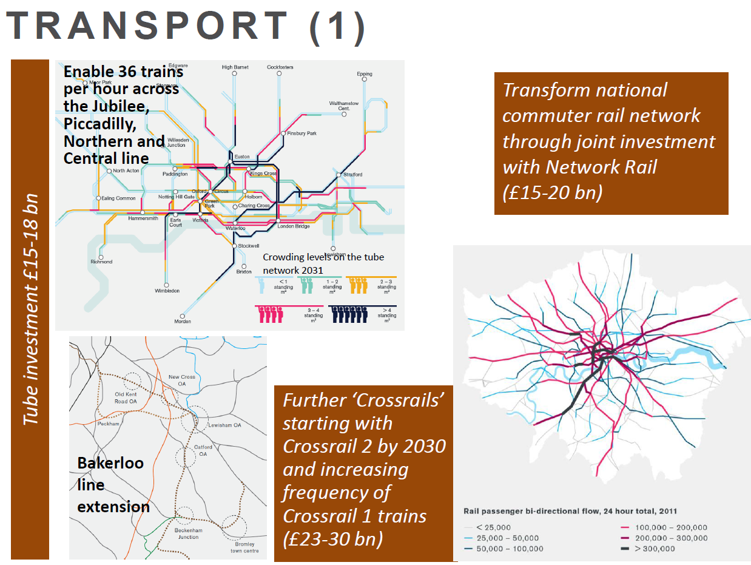

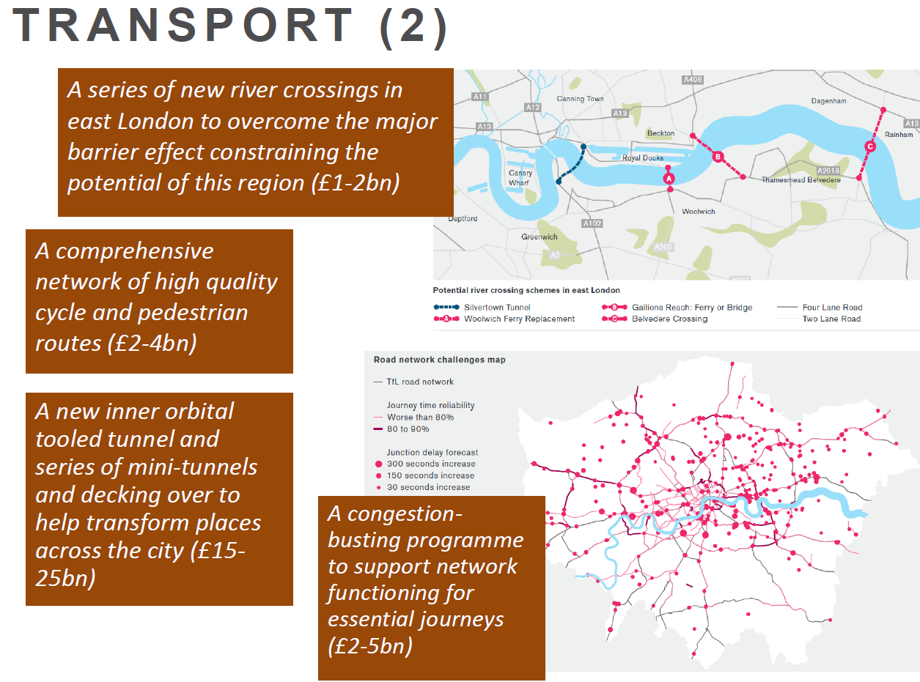

SM suggested that we can enhance and expand the All London Green Grid to provide a network of green infrastructure providing flood protection, shade, biodiversity, space for cycling, walking and recreation and a more attractive environment.

Digital Connectivity should encompass 5G before 2020, open data (data that should be freely available to everyone to use and republish as they wish, without restrictions from copyright, patents or other mechanisms of control) to encourage and disseminate new ideas, and fibre and wireless access to the internet.

Energy. The objectives of Energy Policy should be •Security of supply, •Affordability and •CO2 reductions.
National and international supply, Investment ahead of need which requires regulatory reform and efficient local production
Other objectives are •Access to market, •Better planning and •Local projects for which two scenarios have been considered:
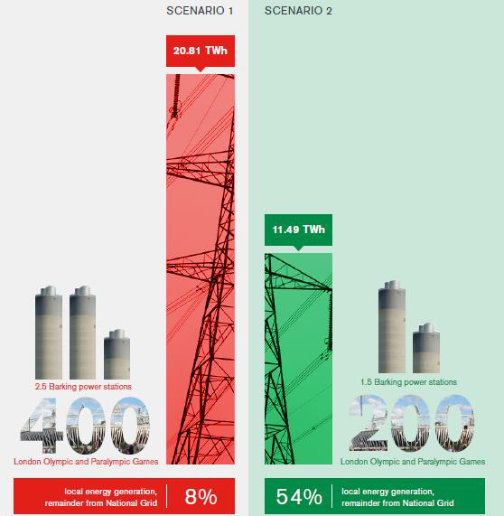

Water. On present assessment there will be an expected deficit in water supply of over half a billion litres a day by 2050. This is accounted for by a variety of elements which need to be addressed: In order of significance these are leakage reduction, more water metering (and higher tariffs), better trading with other water companies, groundwater and aquifer recharge schemes and reuse of waste water. There also needs to be transfer of water from The Oxford Canal.

More waste water facilities are needed.

Spatial Aspects: In developing a London Plan Review by 2019/2020 four spatial scenarios have been considered, graphically examined for their growth distributions below:

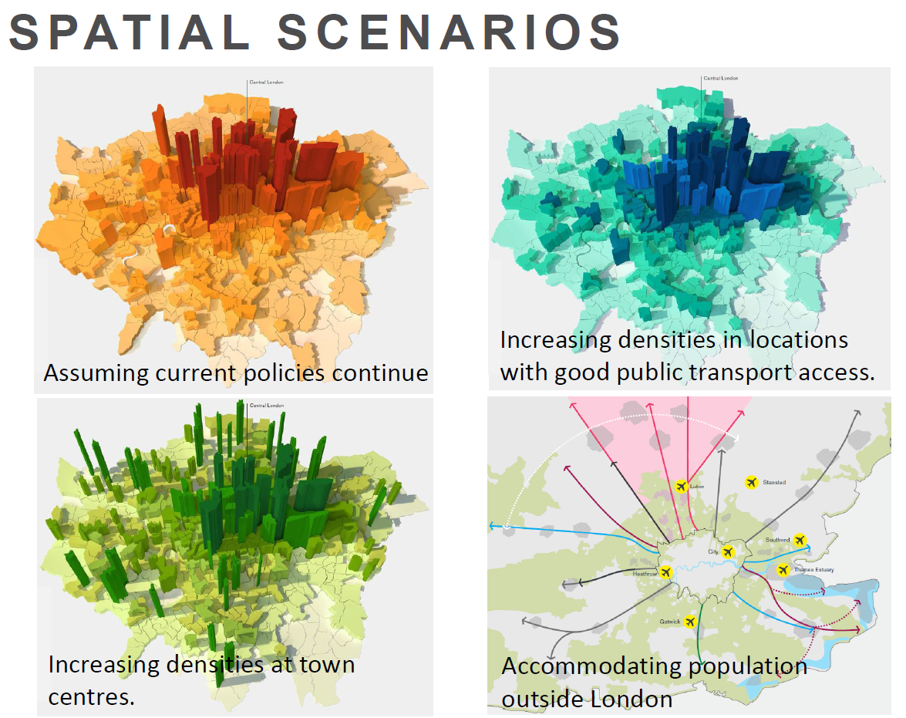

(Promised GLA Post Meeting Addition:) The spatial scenario figures are set out in appendix 1 of the transport supporting paper which was published alongside the consultation report in July.
(http://www.london.gov.uk/sites/default/files/transport_supporting_paper.pdf )

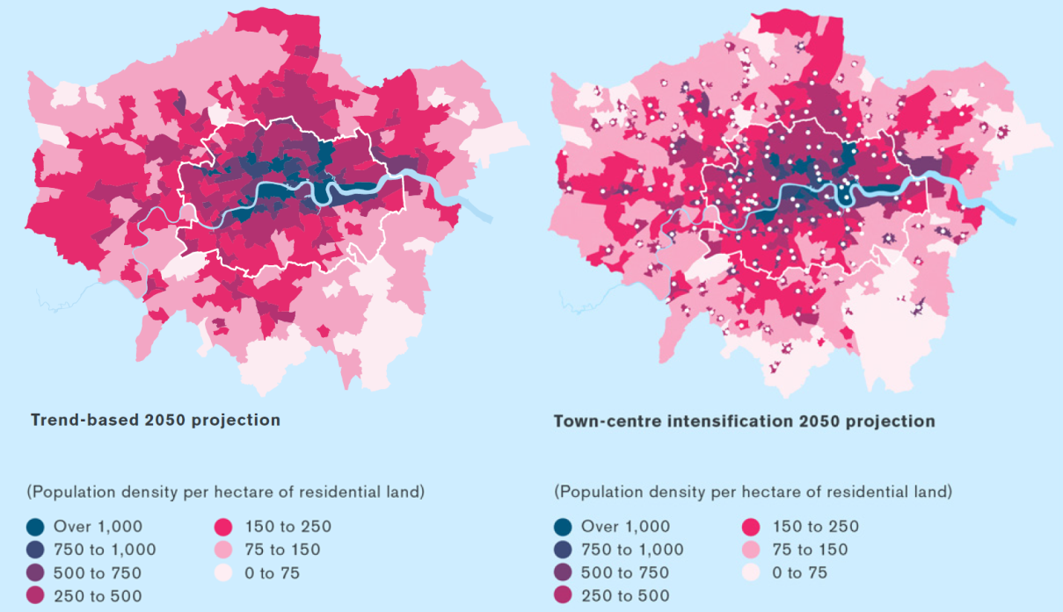

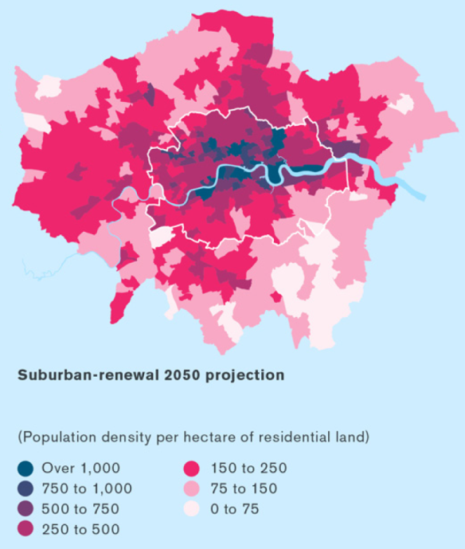
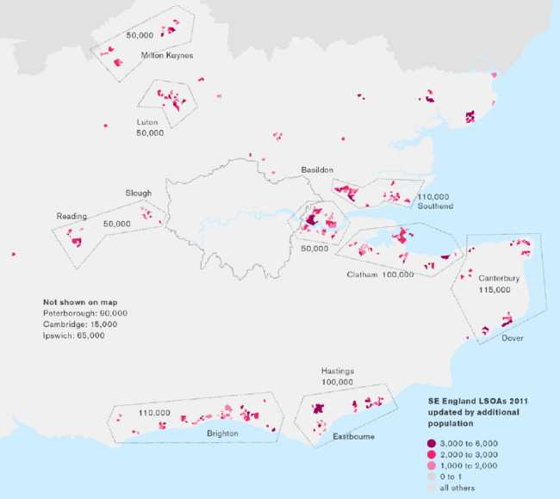

These are of course not mutually exclusive options.

The possible forms of sustainable growth proposed are:
•Within London (town centres, Opportunity Areas, surplus industry, other large sites); beyond London e.g. expanded towns, new towns, rail corridors.
•Networks for sustainable growth: rail, road, ports, air, ‘local’ modes and freight.
These are combined with the
•Environment for sustainable growth: water, energy, minerals, climate change, green belt.

Better Delivery: Mechanisms are needed to meet in particular the following challenges:
- Split governance across and within sectors
- Infrastructure development spans political cycles
- Regulatory frameworks inhibiting developments, innovation and efficiencies
- Pace of innovation and technological change

Changes to Governance, Regulation and Funding need
•London Infrastructure Delivery Board.
•Work to gain cross party support and commitment.
•Push for reforms to the regulatory systems to enable delivery ahead of demand, encourage innovation and transparency.
•Fiscal devolution – greater local control.

A new London Infrastructure Delivery Board is being developed to update actions agreed, Start working together on specific sites to develop improved delivery methods and ways of working – such as Old Oak Common, Thamesmead, Upper Lea Valley.
Developing a Programme plan 2015-2050

Work is required to encourage/improve:
Innovation Regulation, Skills and employment Connectivity, Fiscal devolution Financial rules for investment and Private finance

Funding: The following shows the large extent of staged cost estimates

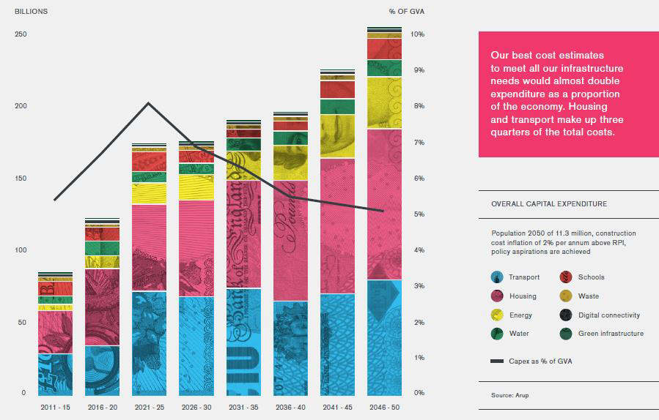

Paying For it

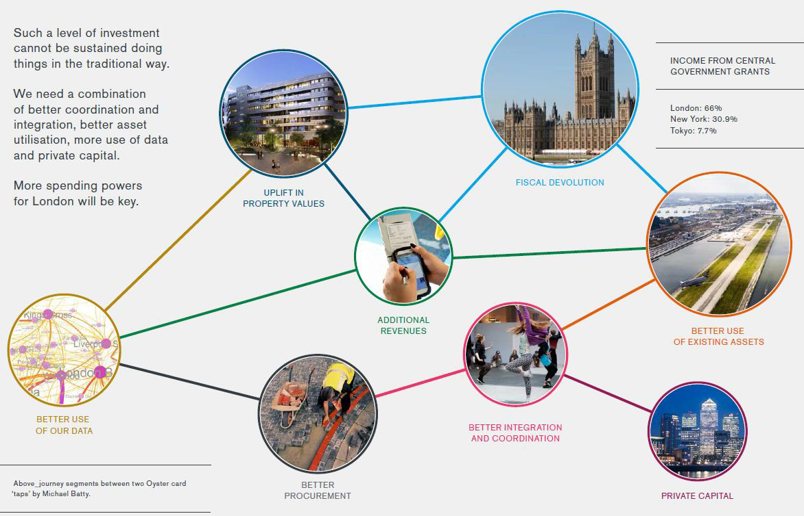

Consultation
Responses

200+ received
Local authorities
Shouldn’t influence spatial strategy
Commuter corridors
Regional planning
Communication and consultation
Green Belt
Thames Estuary Airport (TEA)

Other
Integrated delivery
Prioritisation criteria
Climate change
Housing delivery
Social infrastructure
Economic rationale
Congestion

Next Steps
Final outputs published late March:
•LIP 2050 – 2015 update report
•Programme Plan 2015-2050
•Interactive maps and timeline to 2050
•Summary of consultation responses

This is the start rather than the end of the process.

Brian Waters thanked the speaker, commenting that it was very interesting that LIP is blind to political cycles.

Corinne Swain (Arup) responded. She said that she and Martin Simmons had considered the report on behalf of TCPA and Arup. This involved a lot of work on costings and the funding gap. The review welcomed a new style of plan, concentrating on Infrastructure Delivery. It is more reactive, providing a way of bidding for funds and resulting in a different long term vision, requiring foresight in its vision of cities. It may also be seen as a way back into Strategic Planning as discussed in 2010. It has links back to London Finance - City Empowerment with a Delivery Board. The Utility Companies may consider spatial distributions at the regional level only, if they think spatially at all, though they tend not to. The approach offers them a way to buy into the process. LIP involves considerations of low energy, carbon reduction, population projections and business planning. Planning and property scenarios contribute to this – considering options such as intensification versus dispersal etc.
Quantification of the options indicating costings and controls assuming a fixed population growth (11.3 m by 2050) as town centre intensification, diversification around high public transport nodes and planned rail growth. The concerns of local authorities about the impact of the proposals should, in TCPAs view, be met by closer local authority collaboration.

There could however be a wider consideration of options such as reviewing Green Belt and Colliers report to the London Society. Green sprawl Our current affection for
a preservation myth? http://www.londonsociety.org.uk/wp-content/uploads/2014/12/Green-Sprawl-Our-Current-Affection-for-a-Preservation-Myth.pdf
Other scenarios should include the proposals need to reflect City Empowerment – such as the Northern Powerhouse, which would imply lower growth for London, land beyond the south east and a Randstad model. Green infrastructure has been covered but more is needed on social infrastructure and health. Housing needs a special chapter.

The new runway proposals are not scuppered by Davies. There is too much emphasis on CAZ and the emphasis on radials, but this is considered a welcome start to the process.

Duncan Bowie reitierated the need to consider the wider south east, and that LIP should not consider the confines of the London Plan as its boundary. Relations between London and rest of UK/ Regional need rebalancing. Regional planning should be reintroduced to avoid planning in a vacuum. Wealth disparities within the south east are not adequately discussed. Housing is the most acute issue with the problem being how planning mitigates its imbalances of need, notably in spatial distribution. The social costs worsen this for example in increasing travel costs to more remote housing. London and the south east need to be brought together into Metropolitan Regional Government (a new outside London SERPLAN) (The next TCPA magazine will include discussion of this).

John Worthington spoke about the combined effects of process and costs and their importance to infrastructure planning. Citing the case of High Speed Rail he drew attention to London’s combined roles as a Capital and Global City with its relationship with Continental Europe. The huge impact of demography with its centre focussed on the combination of Greater Metropolitan London (population over 20 million) and North West Continental Europe (i.e. Northern France, Belgium, Randstad, Ruhrgebiet) with over 30 million.
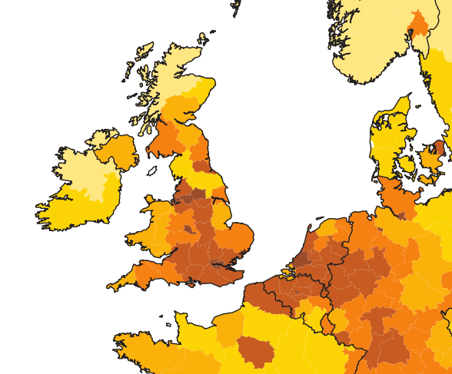
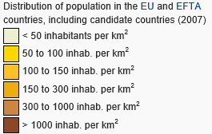

In this context HS2 links to Birmingham, Manchester and Leeds make more sense. High speed is less important than continuous flow with close attention to overcoming social problems of baggage handling, different operators, passports etc. notably at nodes and junctions. JW was critical of current metropolitan Green Belt policy for its adverse effects on movement. He also urged greater co-operation between the many agencies involved in infrastructure delivery, contrasting this with the current “silo” mentality. He advocated more talks between cities co-operating with the State, increasing exchange of information to give greater confidence that the projects will happen, more collaboration of the City Regions, deliverers and suppliers and citizen collaboration, notably by change makers such as RSA, The Academy of Urbanism and Centre for Cities. He cited the case of Toulouse airport which funded major works using state and its own money.

Corinne Swain speculated that transport should be free and the telecommunications groups were increasing their interest in transport.

Judith Ryser spoke of the 12 Netherlands Cities collaborations and wondered how to encourage greater co-operation between London Boroughs or how they should seek to attract more money from the private sector. Also she advocated City States working closely with the State to deliver.

Mike Coupe considered that planning was not rigid and that the Scottish Referendum has “let the cat out of the bag” as a precedent for other regional collaborations. The relationship with the southeast needs to be rethought.

Michael Edwards thought it essential to add to present housing and there needs to be a wider debate to encourage more popular housing gains. The housing scenarios so far produced are a little primitive. He thought density debates should be replaced by improved graphic design of schemes.

Tom Ball thought a wider discussion was needed involving all housing agencies, and thought 50,000 new houses a year is wholly unrealistic. He was concerned with overcrowding of houses, footways, the underground network etc. which suggest the need for growth outside London. He suggested we should ask what was the right distribution of people over the wider area of England and Wales. Health, schools etc do need also to be considered as parts of infrastructure.

Brian Waters said that the market in rental housing should be a part of the new housing provision. People were invited to read a thoughtful paper The London Recipe – How Systems and Empathy Make the City - by Charles Leadbetter of the Centre for London.

DISCUSSION TOPIC
- “Nothing Must be Allowed Simply to Happen” Present Day Forum Review of the Article “Non Plan: An Experiment in Freedom” which appeared in New Society March 1989, by Reyner Banham, Paul Barker, Cedric Price and Peter Hall. Topic introduced by Drummond Robson

This “work in progress”presentation was thought more suitable to be developed into an article in Planning in London: set out as the original “Non Plan” case followed by a practitioner’s reflections today in the context of widespread uneasiness with planning practice outcomes and the legal, technical and political processes which produce them.

- Minutes of the Meeting held on Monday Monday 8th September at RICS HQ 12 Great George Street (Parliament Square) London SW1P and matters arising. Our host was Abdul Choudhury.

These were accepted with no matters arising.

- Treasurer’s report.
None
- Next Meeting.
The next quarterly meeting of the National Planning Forum is to be held on Thursday 26th February. Forum members are invited free to Dentons UKMEA LLP, One Fleet Place, London EC4 7RA at their meeting to a wide audience organised jointly with Cambridge University Land Society with the present title 'The Politics of Planning.'
Its aim is to enable the property, planning, and development industries to engage with the main political parties ahead of the general election.
Speakers confirmed include:
Julian Barwick - Development Securities
Emma Cariaga - British Land
Terry Farrell/Mat Farrell - Farrells
Paul Finch - Architects Journal
Roger Heffer - Savills
Liz Peace - Chief Executive, British Property Federation
Simon Marsh - RSPB
In view of this the next normal Forum meeting is due to be held in late March after MIPM (on 10th-13th March 2015), to which it is hoped that Peter Murray of the London Society is to be invited. It is also proposed to discuss “London’s Blockbuster Schemes”.
- Review of standing items.
None
- AOB

None.

