www.planninginlondon.com
Minutes of the meeting on on Wednesday 14th September at UCL in room LG01, Central House, 14 Upper Woburn Place WC1H 0NN from 2.30 to 5.30pm. Our host was Michael Edwards.
Present: Brian Waters (Chairman)
Andrew Rogers: Association of Consultant Architects
Dan Lewis: CE Future Energy Strategies
Duncan Bowie: University of Westminster
Jessica Ferm: UCL
Judith Ryser: Isocarp/Ugb/Cityscope Europe
Leigh Thomas: Colliers International
Marc Vlessing: CEO Pocket Living
Michael Edwards: UCL
Owen Wainhouse: RIBA
Peter Eversden: London Forum
Richard Lee: Co-ordinator of Just Space
Riëtte Oosthuizen: HTA Design LLP
Ron Heath: Living Architects
Stephanie Pollitt: BPF
Tom Ball: London Forum
Drummond Robson: Honorary Secretary and Robson Planning

Introductions and Apologies.
The Chairman thanked Michael Edwards and Jessica Ferm for arranging the venue, and Michael, Richard Lee of Just Space, Marc Vlessing of Pocket Living, Duncan Bowie and Riette Oosthuizen for introducing topics for discussion. Apologies were received from Lisa Fermaner: City of Westminster LB, Michael Bach: London Forum, Michael Coupe: London Society, Tim Wacher and Jonathan Manns, Colliers International.

DISCUSSION TOPICS
- Londoners’ own plan for London, Just Space network of community organisations
The topic will be introduced by Michael Edwards of UCL, Richard Lee, Co-ordinator of Just Space.
See tabled document https://justspacelondon.files.wordpress.com/2013/09/just-space-a4-community-led-london-plan.pdf
Michael Edwards explained the need for a Community Plan saying there was a democratic deficit in London’s plan making which resulted in less than fairness for all. Divergences of wealth and poverty, falling real incomes, overcrowding and increased homelessness, declining housing stock through right to buy, high costs of transport, more concentrated job activity in the centre with resultant long journeys to work and increasingly expensive measures to overcome this (Crossrails 1,2 and 3).
He criticised the processes of consultation in plan making as being weighted to suit the plan makers rather than the populations being served.
ME explained that JustSpace, formed 10 years ago is not a political party, or Campaign, Think Tank or NGO. It relies on mutual self support and technical support engaging with the Planning System. It has prepared a set of policies based on consensus of those involved and is multi scale.
It seeks to seize the initiative rather than commenting on or trying to fix the current plan, but rather aimed at what the plan should be. ME cited his experience in the King’s Cross Railway Lands development.
It has been suggested that London has been recovering since 2007 but this assessment needs to be reconsidered if housing costs are taken into account.
Lee Thomas added to MEs assessment to cover density and density control, workplace versus housing land, lifetime suburbs and implementation. He emphasised the inappropriate tall buildings strategy, lifetime suburbs where over crowding solutions are unwelcome, and mixed development opportunities.
Jessica Fermaner spoke of the undue emphasis on the lack of economic diversity in the CAZ and underplanning of the worth of High Streets and rapid recent declines in safeguarded available industrial land. The key policies set out extensively in the Community Led Plan itself are as follows:
Policy Proposals
A Green and Localised Economy
A. Encourage changes in consumption and production to achieve a circular economy, setting targets to reduce all types of waste, supporting reuse, repairing and recycling activities (for example through networks connecting surplus food, building materials, furniture, IT equipment etc with people in need). Ensure support and funding schemes are easily accessible to SMEs, social enterprises and local community groups for education and training programmes (for example, waste management, resource-efficiency, accessing local
supply chains).
B. Raise the environmental performance of the building stock (see Housing chapter) and re-configure settlement and urban patterns to reduce the need for travel (see Transport
chapter) and the reliance on non-renewable energy sources (see Environment chapter).
C. Protect London’s poly-centric economy by supporting development which does not compromise the economy and diversity of local high streets, town centres of all scales, local
shopping parades, markets and shopping centres, particularly outside the CAZ.
D. Support development which fosters Lifetime Neighbourhood principles, as defined in the Implementation chapter, with a focus on creating well-paid and secure local jobs and access
to local amenities and services affordable to everyone.
E. Planning applications for major new development will take into account the need for new workspace to accommodate a mix of economic activities in all sectors, including community
and voluntary organisations, social enterprises, education, play, religious, health and care facilities.
F. Recognise and protect street and covered markets as a) a source of healthy and cheap food and other goods b) a social benefit c) a source of independent business and local supply d) providing local employment e) an opportunity for start-up businesses. Local authorities should seek to retain control of management and rent-setting and must consult with traders
and customers on future proposals. The London Plan should include a database of protected markets.
Diverse Economies
A. Recognise and promote the diversity of London’s economic activities and the contribution they make across all sectors and scales. Evidence, case studies and a collaborative approach should form part of the Economic Evidence Base, Economic Development Strategy, Town Centre, Retail and Employment Land Reviews.
B. Planning decisions should recognise and take account of existing local economies and require detailed evidence of the reality on the ground, including for example business audits, mapping supply chains and business connections, interviews with business owners, as well as assessments of local labour markets.
C. The London Plan should no longer set targets for managed release of industrial land. There should instead be a presumption against further loss unless a case can be made to the Mayor demonstrating genuine long-term vacancy on specific sites.
D. Address the cumulative loss of workspace by working to increase capacity suitable for a diverse range of economic activities, including but not limited to: workshops, studios, small retail units, industrial units, yards, sheds, warehouses and wharves.
E. Foster innovations in the design, finance and management of development schemes so industrial and residential uses can co-exist, for example when single storey commercial
buildings are replaced with multi-storey residential and workspace buildings.
F. Plan for the long-term infrastructure needs of industry. The London Infrastructure Plan 2050, London Energy Plan, Transport Strategy and other related strategies will assess
and address the infrastructure needs of businesses in all economic sectors.
G. Protect clusters of small and independent businesses and ethnic and migrant traders which have a unique and irreplaceable character and assist communities to be resilient in the face of rapid change, particularly in areas undergoing regeneration and growth
H. Support capacity building in London’s diverse business communities (industrial businesses, Small and Medium Enterprises, Ethnic and Migrant Businesses, market traders)
to encourage business-led solutions to redevelopment and change, such as in Opportunity Areas, regeneration areas and business-led neighbourhood forums.
Caring for Existing Homes
A. The Mayor and the boroughs will support maintenance and enhancement of the condition and quality of London’s existing homes to ensure that new homes delivered are additional to existing stock rather than replacements. This will include designating energy efficiency as an infrastructure priority and using infrastructure funds to deliver stable, long term investment to implement a locally-led programme for the upgrade of all existing London homes to B and C on an Energy Performance Certificate.
B. Boroughs should develop policies and proposals to reduce environmental impact, particularly lifetime and embodied carbon emissions, through the sustainable retrofitting of
existing homes. In particular they should:
— Prioritise adaptations to the homes of older residents.
— Prioritise fuel-poor and vulnerable households .
— Identify synergies between new developments and existing homes.
— Though retrofitting of energy and water efficiency measures, decentralised energy and renewable energy options.
— Make the link with public health programmes (for example, a boiler on prescription programme for those most vulnerable).
— Include minimum energy efficiency standards as a condition of licensing in the private rented sector.
— Encourage energy rights initiatives and community based energy projects.
C. Refurbishment options for existing council or housing association estates should include proposals to retain, enhance or deliver green and garden spaces, play and youth
provision and community space and buildings.
D. Any replacement of not-for-profit rented home should be carried out on the basis of like for like in terms of tenure, rental cost and size.
E. Proposed regeneration of council or housing association estates should require comprehensive, independent analysis of social, environmental (including embodied carbon) and economic benefits of all proposed options and a ballot of tenants and leaseholders. Options should always include refurbishment.
F. Social, health and wellbeing indicators of existing residents should be incorporated into decision-making around regeneration schemes. These should be routinely monitored
post-regeneration, with tracking of those displaced. A model for this should be prepared or commissioned by the Mayor in collaboration with community, tenant and voluntary sector
groups. To inform this, the Mayor should commission analysis of the impact of housing displacement on health and wellbeing.
G. The Mayor should commission analysis and monitoring of the relationship between income, poor housing, health and wellbeing.
H. There should be ongoing monitoring of poor health and wellbeing as a result of overcrowding.
Quality of New Homes
A. New homes should be built to last a minimum of 125 years. The design and construction should ensure adaptability so that retrofitting and rearrangement of internal spaces
can occur.
B. New homes should be energy positive.
C. All homes should be built to lifetime homes standards.
D. Communal meeting spaces and green and play space with good natural light should be integral to the design of new housing blocks and estates.
E. A new more sophisticated density matrix that combines housing, social and community infrastructure should be developed. This will take into account household income, financial accessibility to transport, proximity of accessible (both in a physical and financial sense) sport and leisure, community, youth and safe play facilities, levels of overcrowding and preservation of local character.
F. The Mayor’s design team should review all major schemes from the point of view of good design and their advice should steer the GLA officers’ response.
Not-for-Profit Rented Homes: Policy on Housing Types and Definitions
A. The London Plan should make clear to what extent, through reference to housing costs and incomes, the housing needs of households with less than median income levels will be addressed.
B. As most of the current London Plan ‘affordable housing’ products are not affordable to the majority of households in London, the term should be removed in any Mayoral or borough planning documents.
C. Assessments of the requirement for not-for-profit rented homes should be carried out and included in the London Plan.
D. Not-for-profit rented homes are defined as including community-led housing, which takes many forms, as well as social rented housing for which rents are ring fenced to cover the running costs of existing homes (management, maintenance and repairs).
Participation in London Wide Housing Policy
A. The Mayor will convene a Housing Forum (and a supporting community engagement sub-group of the Forum) that will ensure tenant engagement and input is at the heart of the housing strategy for London, its remit including policy, delivery and monitoring functions and with a full representation of council tenants, housing association tenants, community-led housing tenants, private renters and voluntary and community sector groups representing
those with particular housing needs.
B. Given the Mayor’s powers over housing in London, the Mayor should provide a grant funding programme to support the activity of tenants groups, renters groups and other
community groups at local, Borough and London-wide levels.
This could include the resourcing of a London Private Renters Forum, the existing London Tenants Federation and a London making at the GLA.
C. The Mayor will encourage Boroughs to work closely with Tenants and Residents Associations and borough-wide Tenants Federations or tenants organisations to work in
collaboration with Housing Associations around engagement of their tenants to recognise renters groups and to put in place consultative forums for private renters at Borough level.
Community-Led Housing Policy
A. The Mayor will maintain a London wide register of available land for community-led forms of housing and ensure:
— The register is fully accessible to community builders, neighbourhood forums and other community interests
— The register includes data on interest and demand for community-led housing, and how the sites on the register are allocated.
B. The Mayor will make available a package of support for community forms of housing that includes:
— Promote supportive financial institutions, such as Unity Trust, offering low cost loans.
— Local Authorities to identify land and do the appropriate checks (not placing the onus for this on the community groups).
— No requirement to tender to be the developer (EU regulations exemption).
— Community builders to be exempt from CIL and S106 they will provide community amenities/community benefit as a matter of course.
— GLA fund for a mentors programme, capacity building of community builders, expertise for feasibility or pre-feasibility studies, partnering with smaller housing associations.
— A knowledge bank to develop Borough understanding and retain the expertise of community-led housing groups.
Private Rented Sector
A. The Mayor to provide support for Borough-run social letting agencies and landlord licensing schemes which should encourage landlords to offer longer term tenancies for private
tenants in homes that are both energy efficient and meet decent home standards.
B. The Mayor should develop rent stabilisation methods for regulating changes in rents at the end of assured shorthold tenancies.
C. The Mayor to simplify and improve the policy on Empty Dwelling Management Orders. This policy permits Boroughs to municipalise the management of empty properties for
compulsory private rental.
D. The Mayor to commission research into large scale PRS development and produce detailed planning guidance.
E. The Mayor to support a Private Renters’ Knowledge Bank which would develop Borough and voluntary sector understanding and retain the expertise of private renter advice and support groups
Policies Dependent on New Legal Powers
A. The Mayor to seek devolved powers to introduce city wide rent control, based on a range of rent control methods on which research and development should now begin.
B. Repeal of Section 21 ‘no-fault’ eviction should be urgently sought by the Mayor in his negotiations with government over devolved powers.
C. The Mayor to seek powers so that landlord licensing can be made mandatory across London with a commitment to ethical lettings, regulation of informal housing, minimum energy efficiency and anti-discrimination standards.
D. The Mayor to devise measures to regulate institutional ownership of housing for private rent (build-to-rent or existing buildings).
Policy on Housing Targets
A. To meet existing need and to address London’s backlog of need over a five year period a target of 30,000 not-for-profit rented homes per annum would need to be set.
B. Targets should be set for three, four and five bedroom homes.
C. Targets should be set for reducing overcrowded homes.
D. Public land should be held for not-for-profit rented homes (this includes community forms of housing), with the land provided for free as a community asset transfer or long lease.
This applies to all public bodies, including Local Authorities, NHS, Transport for London, Network Rail and Housing Zones.
Transport Objective A
Transport Policy A1. Lifetime Suburbs
Introduce lifetime suburbs in Outer London, scaling up lifetime neighbourhoods, to reduce the need to travel by greater share of jobs, services and homes.
Transport Policy A2. Planning and Making
the Transport System Work Better
A suite of measures, mostly small-scale, but targeted to achieve in an incremental way a denser coherent and convenient travel network. Mayoral Transport Strategy should have expression not only London wide but also at sub-regional level ensuring that sub-regional plans are open to public scrutiny.
Transport Objective B
Transport Policy B1. Promote Active,
Affordable, Integrated and Accessible Travel
Support and improve throughout London opportunities and facilities for walking, cycling, public transport, including their affordability, integration and accessibility. Implement road
space reallocation including reducing or eliminating car travel lanes in specific areas to create additional space for walking, cycling and the public realm. Mini-Hollands to be brought
in for all 32 Boroughs, the City and Mayoral Development Corporations.
Transport Policy B2. Outer London
Greater emphasis on maintaining, enhancing and extending Outer London’s public transport services, particularly bus services and Orbital Rail, and on integrating with transport for the wider South East region.
Transport Objective C
Transport Policy C1.Improve the Environment
Strengthened Low Emission requirements, strong road
traffic reduction targets and avoiding traffic generating
transport schemes.
Transport Policy C2. Tackle Congestion and Pollution
Road Traffic Reduction Target Setting and Road User Charging (that is equitable and proportionate) for all of London to tackle congestion and pollution and create a fairer share of space for cyclists and buses, with revenue used to support sufficient, reliable, safe, affordable and accessible public transport.
Transport Policy D1. Promote an
Integrated Approach to Freight
Promote an integrated approach to freight with a network of consolidation hubs and managed distribution for the final leg of delivery. Shift road freight to rivers and canals by implementing the Blue Ribbon Network. Protect and enhance water transport opportunities, facilities and services.
Implementation Objectives
— A comprehensive review of the existing delivery models of Mayoral Development Corporations, Opportunity Areas, Intensification Areas and Housing Zones.
— Promotion of lifetime neighbourhoods which build on, rather than eradicate, the existing qualities and diversity of London’s neighbourhoods.
— Recognition of the importance of Community Assets / Spaces for the well-being of Londoners and for achieving lifetime neighbourhoods.
— Tools that are open and transparent such as the Social Impact Assessment, that assess existing uses in an area, allow the consideration of alternative proposals and give a high value to social sustainability.
— Comprehensive and inclusive monitoring indicators (Key Performance Indicators or KPIs) to provide a robust evaluation of the strategic aims of the GLA Act and the London Plan. For example, a KPI to monitor effective community participation in the preparation and implementation of the London Plan.
— Governance arrangements at the GLA that provide for the representation and participation of all Londoners, such as through a Mayoral Social Compact with Londoners, detailed in chapter 2.
Opportunity Areas
Policy Proposals
A. There must be a full review, documentation and assessment of Opportunity Areas to date.
B. Until this takes place, there must be a moratorium on the declaration of any further Opportunity Areas and no more approvals of Opportunity Area Planning Frameworks.
C. Already designated Opportunity Areas must function more democratically and adhere to strict public participation principles.
Lifetime Neighbourhoods and Community Infrastructure
Policy Proposals
Strategic
A. London will demonstrate its commitment to developing an inclusive and sustainable city through the achievement of lifetime neighbourhoods that support empowered communities in which local employment, social and community facilities, shops, streets, parks and open spaces, local services, decent homes and public transport bring people together and are affordable and accessible to everyone, now and for future generations.
B. In Outer London, lifetime neighbourhoods will be an important tool in achieving a more balanced economic development. ‘Lifetime Suburbs’ will provide a real mixed development strategy for Outer London, reducing the need to travel, travel times and the over-dependence on the centre of London.
Planning Decisions
A. To measure and evaluate the impact of development proposals on existing residents and businesses in a neighbourhood, Social Impact Assessments will be undertaken. This involves
the Boroughs, supported by the GLA, carrying out detailed analysis of what an area already contains: its housing, jobs, community facilities, locally appreciated buildings, and so on.
A report should be prepared for public consultation and made a part of evaluating the viability of any new plans.
B. Social Impact Assessments will:
— Be informed by impact assessment criteria that are prepared by the Boroughs together with the voluntary and community sector.
— Acknowledge the social and health costs (alongside the economic and environmental costs) of relocation or displacement
— Be recognised as an important tool in planning decisions, alongside the Equality Impact Assessments required by the Equality Act 2010.
— Be conducted and published independently of the developer to ensure impartiality and transparency in the decision making process.
— If mitigation strategies to offset the negative impact of development proposals are proposed, they will be scrutinised and the effectiveness of their delivery investigated.
— If the mitigation strategies are considered inadequate, the communities affected (whether residents, traders or community assets users) will be balloted.
Local Plans
The Mayor places a high importance on the protection of existing community infrastructure provision and will encourage initiatives that promote the resilience of community assets.
Boroughs should have policy requirements:
A. With the presumption to protect and enhance existing community assets that meet the needs of particular communities.
B. On the affordability of community floor space and security of tenure (lease agreements).
C. Valuing the ‘irreplaceability’ and uniqueness of some community assets. Planning applications that do not enhance this ‘uniqueness’ of place will not be supported.
D. Empowering local community networks, in alliance with research organisations, to evaluate the socio-economic value of community assets, gathering information from members
and users.
Where re-provision of community infrastructure is required, this will include conditions enabling the existing users of the space to resume their use of the space on equivalent terms.
Neighbourhood Plans
Neighbourhood Plans are an important mechanism for the implementation of lifetime neighbourhoods. They are a platform for communication and participation, with the
potential to engage all groups in the design and delivery of planning policy and implementation.
The Mayor will work with the Boroughs and
Voluntary and Community Sector to:
A. Provide programmes of capacity building for public officers, including cultural awareness and community development.
B. Implement measures to support under-represented and excluded groups to take advantage of the Localism Act 2011 and especially the community right to bid and asset transfer schemes, community economic development, community right to build and community right to neighbourhood planning.
C. Publicise the Boroughs’ corporate asset management strategy and lists of assets available for transfer to community groups.
Monitoring
Policy Proposals
New indicators for measuring London’s economic success should include those developed by the New Economics Foundation.
A. Good jobs: % of the labour force that has a secure job that pays at least the living wage (using ONS Labour Force Survey Data).
B. Wellbeing: average life satisfaction on scale of 0–10 (using ONS Measuring National Wellbeing survey).
C. Environment: Carbon emissions in relation to the minimum limit set to avoid dangerous climate change (using defra data); similarly for air quality.
D. Fairness: ratio between after-tax incomes of top 10% and bottom 10% of households (using ONS data on The Effects of Taxes and Benefits on Household Income); this should be
computed both before and after housing costs.
E. Health: % of deaths avoidable through good quality health care / public health interventions (using ONS Avoidable Mortality statistics).
Other additional indicators should cover:
F. Financial success of households, after meeting housing costs.
G. Diversity of business sectors (for example in terms of size, number of employees and required floorspace; social and cultural, number of ethnic and migrant businesses etc).
H. Strength of local supply chains (for example interlinkages between firms, delivery distance, time and cost etc).
I. Sustainability of resource use (for example capacity of renewable energy equipment installed; amount of waste generated that is not recycled).
J. Environmentally-damaging travel and transport generated by economic activity (for example number, distance and cost of work-trips, deliveries, air-travel).
K. Gender disparities in terms of wages and access to the labour market (for example a Gender-sensitive Regional Development Index).
L. How much of the profits generated by businesses based in London are:
— Paid in tax (and of that, how much is returned through central allocation to the GLA and the boroughs).
— Re-invested into business (as opposed to paid out as dividends and interest).
— Spent on wages (and whether this is rising over time, as growth goes up, or not).
— Distributed through dividends or profits to local community members who own or have invested in local businesses.
— Distributed across socio-economic classes within the population.

In the ensuing brief discussion Peter Eversden was concerned that the Boroughs had not delivered on London Plan proposals and what should be in the London Plan compared with what should be left to the Boroughs. Boroughs had been very slow in updating their local plans with the risk that cases are lost as being no longer justifiable.
Duncan Bowie considered the Just Space material to be very valuable in strategic discussions notably in establishing suitable residential quality.
There are recent research reports available to The Mayor on diversification and change to the density matrix to increase ranges which are likely to result in more hyperdensity schemes He was concerened that we have lost sight of who we are building for. The 2003 density zones were not implemented as intended. Emphasis on the compact city has meant that suburban options are not being considered. He also thought that Estate regeneration options were tricky to achieve. He suggested that schemes should be considered on a case by case basis to see if there was adequate transport to support intended densities.
PE concurred by saying that the 2015 Infrastructure Plan had been “blown out of the water”.
Riëtte Oosthuizen invited consideration of social infrastructure which was proving difficult with a high cost CIL regime which takes away from delivery options, often without using the CIL monies collected. In practice there has been extensive growth of rooftop space, notably in Inner and Outer London. She was concerned that developers needed to be incentivised if they were to deliver new developments. The requirement for 20% starter homes is proving unrealistic.
Tom Ball considered that the lack of new housing was becoming overwhelming in its significance and there needs to be a national Plan to tackle it.
Judith Ryser though impressed with the Just Space investigation was concerned that the proposals lacked pragmatism, saying they seem to be largely symbolic responses rather than amounting to the right strategy to tackle current planning problems. A shorter document may also have more impact.
Dan Lewis suggested the involvement of other Think Tanks e.g. IPPR, Centre for Social Justice etc. Mar Vlessing added London Chamber of Commerce as potential contributor in view of the need for employment retention as well as Housing.

- Productive Planning.
Marc Vlessing. CEO Pocket Living introduced the topic
Members are familiar with Pocket’s approach but a few slides introduced the item and then gave his views as to how policies look to him, how they support/impede the Pocket approach of providing one bedroom apartments for London's city makers. They are compact, 38 sq metre properties and priced at least 20% lower than the open market.

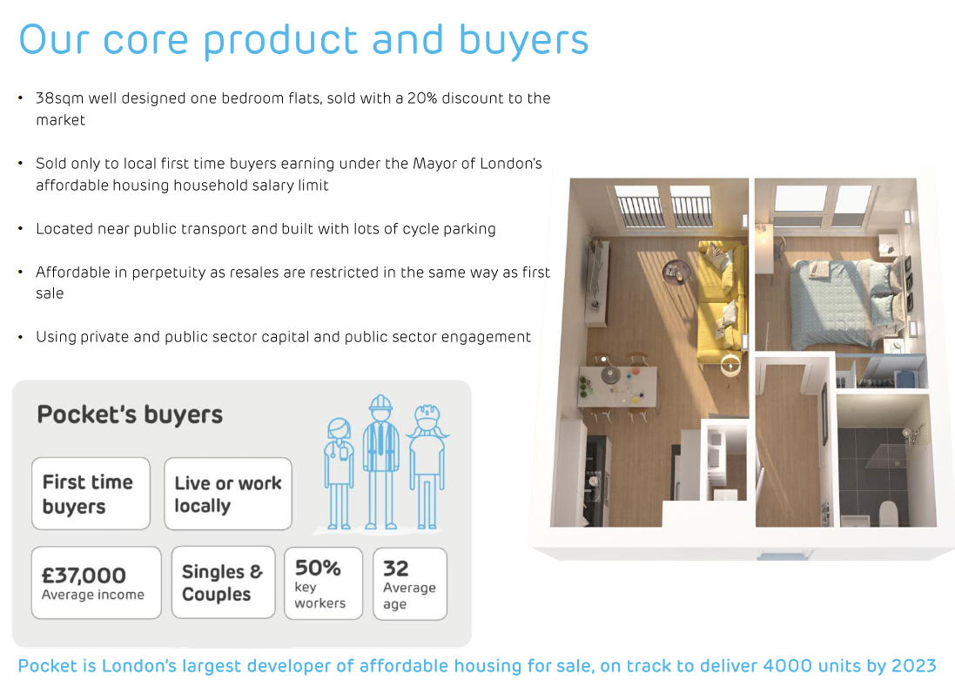
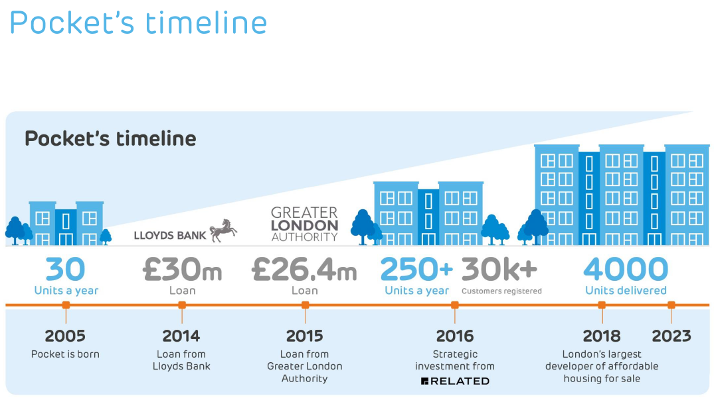
Corporate Finance for £26.4m is working to produce 750 homes per year. The largest scheme to date has been for 45 new homes. Planning permission has been granted for 120 on bigger sites with 50-60% 2 bed and family housing.
However minimal levels of social housing are in fact being realised currently in London. At present only 23% is being achieved compared with a necessary target of 30% which compares with 45-50% in the Netherlands.
MV expressed some concerned about the lack of management and technical expertise to realise schemes at GLA given the size of the task needed.
Ron Heath wondered about the cost of housing to buy and invited consideration of more housing association development but with the requirement that occupiers should live there much longer and not sublet. MV said the average sale equity on Pocket units was £65K. He thought the design life of buildings should be 80 years.
Stephanie Pollitt: BPF suggested that a Field Trip would be worthwhile to look at Pocket Homes. The average cost psf seemed higher than that for volume house builders, which may query their usefulness. MV said the numbers were growing and that there were sites in 13-14 London local authorities.

DR asked about neighbour reactions to Pocket schemes. MV said that people welcomed the fact that most of the occupants were at work all day resulting in quiet environments, and that shops had seen increased income from higher footfall. There is a waiting list of 35,000.

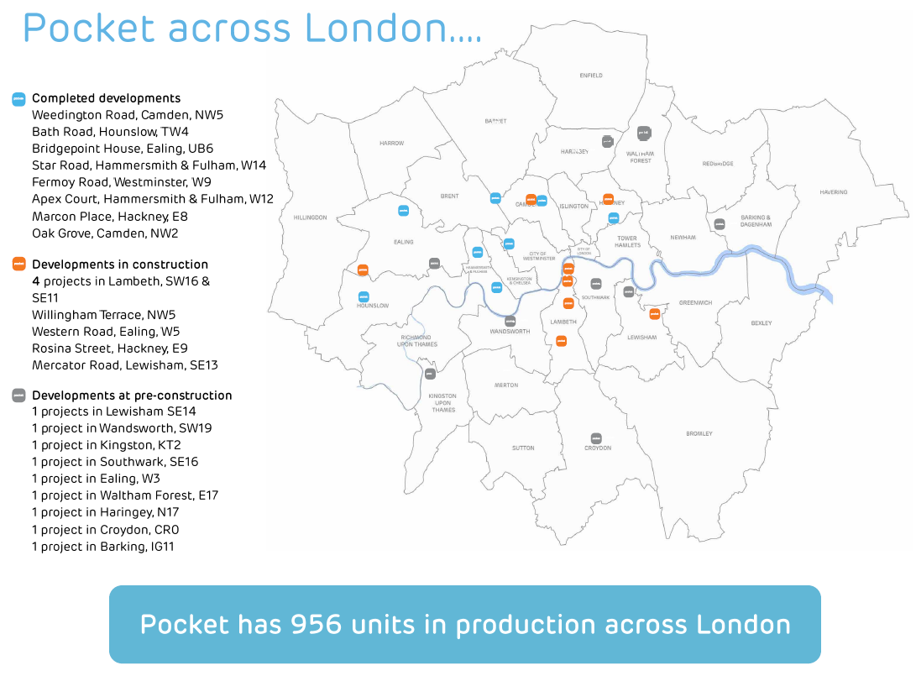
Planning Policy in London
- Great opportunity with Gavin Barwell MP and James Murray
- 50% affordable housing target
- Too rigid and site focused
- Viability expert team
- Improves transparency to address market failure
- Homes for Londoners
- Opportunity for pan-London strategy

How can the lessons learnt from Pocket’s public/private partnerships be used to deliver more housing across London?
- Encourage a full range of housing options
- protect social housing sector (33% market)
- Speed up the designation of public land
- Role of Modular
- London housing regime
- Starter Homes for London?
- Triangulation between GLA, London Local Government and DCLG

Duncan Bowie said that Gavin Barwell has an opportunity to modify the detailed arrangements on starter homes but Brxit has meant there is no time for the necessary secondary legislation to give effect to starter home aspirations. This and the shortage of numbers with adequate competence to frame the necessary legislation suggest that starter homes are unlikely to be realised quickly.
Revised supplementary guidance for the GLA was issued in May 2016 which set out higher requirements than hitherto. It is important to work out what is actually needed, rather than continue to provide for the compact city. Social rent criteria were clearly defined together with a social rent target, but this has been lost sight of. Policy and planning bear little relation to what is needed for different social groups. Funding is critical to housing realisation. Also there needs to be greater flexibility on the investment programme. It is doubtful however whether the government will give GLA the necessary flexibility in the housing investment programme.
Private sector higher density schemes will be dependent on delivering some of the key infrastructure schemes such as Crossrail, HS2 etc.
A new policy paper is in preparation as the result of the abolition of the Outer London Commission exploring where housing should go. CPRE remains protective of the Green Belt but this is now being questioned more widely. It is clearly a topic for future discussion by the Forum, perhaps in December.
DB has written a recent TCPA paper which the Forum thought would be worthwhile to distribute.
In a footnote we learned that Stewart Murray had now joined GL Hearn and Partners.

- Minutes of the Meeting held on Monday13th June in Committee Room 3 at City Hall The Queen's Walk, London SE1 2AA. Our Host was Colin Wilson.
These were agreed.

- Treasurer’s report. Subscriptions are being sought.

- Next Meeting. At Colliers International 50 George Street W1U 7GA on 6th December 2016

- AOB None

