www.planninginlondon.com

Minutes of the Meeting of the Forum held on Monday 9th December 2013 at Port of London Offices at Bakers Hall 7 Harp Lane London EC3R 6LB between 2.30 and 5.30pm. Our host was James Trimmer, PLA’s Director of Planning and Environment.

.

Attendance:
Brian Waters: Chairman
Alan Benson: GLA
Andrew Rogers: ACA
Brian Whiteley: RTPI and Hillingdon
Charlie Peel: Farrells
Deborah Garvie: Shelter
Duncan Bowie: University of Westminster
James Trimmer: PLA
Max Farrell: Farrells
Michael Coupe: London Society and Coupe Planning
Nikolaos Karadimitriou: UCL
Peter Heath: GLA
Richard Lee: Just Space
Ron Heath: RIBA
Shelagh Grant: Housing Forum CE
Tim Wacher: RICS
Drummond Robson: Honorary Secretary and Robson Planning

- Introductions and Apologies.
The Chairman welcomed the speakers and guests. Apologies have been received from Alastair Gaskin, David Bradley, Giles Dolphin, Jonathan Manns, Michael Simmons and Tom Ball

Apologies were also given by Hounslow for reasons of staff shortage and current reorganisation who had been invited since they were also preparing Characterisation Studies. The Chairman introduced Steve Walker from Allies and Morrison, Jim Stride from Thames Water and James Trimmer from The Port of London Authority as the three speakers.

2. DISCUSSION TOPICS

- Preview of The Farrell Review introduced by Max Farrell and Charlie Peel.
Sir Terry Farrell has been asked by Culture and Creative Industries Minister Ed Vaizey to undertake a new, independent Review of Architecture and the Built Environment.

The Review is intended as a rallying call to heighten awareness of what can and should be done and making architecture and our built environment one of the biggest public issues, like health or food. The report is due in January for Ministers with wider distribution of the independent findings in the Spring.

A review panel comprises Peter Bishop, Alison Brooks, Alain de Botton, Hank Dittmar, Jim Eyre, Robert Powell, Thomas Heatherwick, Sunand Prasad, Nigel Hugill,Victoria Thornton, Lucy Musgrave.
The terms of reference are
1. Understanding the role for Government in achieving and promoting design quality in architecture and the built environment
2. The Benefits of good architecture and design, and maximising the uk’s growth potential
3. Cultural heritage and the built environment (looking at whether the desire to preserve the ‘old’ makes it more difficult to encourage good new architecture, and the value of our historic built environment as a cultural asset and in successful place-making.
4. Promoting education, outreach and skills

There has been wide consultation in various forms: workshops, discussion sessions meetings with business, industry and government officials and politicians. It has been funded independently of government.
Aims are to increase awareness of the significance of design quality, promote architects and architecture, and avoid competition between old and new.
There has been analysis of the complex network of government agencies over time

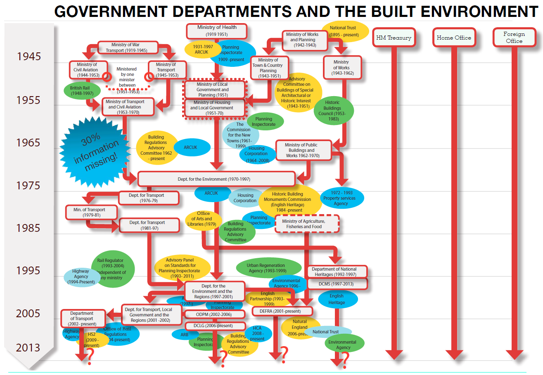
The role of the Treasury: described as one silo but with many fingers.
The aim is to shape views based on past experience, taking account of the shifting global balance of power and the explosion in recent technology.

Discussion
The Chairman asked what the outcome was. MF explained that it was the start of a big conversation in the form of a digital hub in one place. There would be manifesto checklists.
Deborah Garvie suggested that the terms of reference should be widened to encompass housing design, and the social and economic implications of design.
Drummond Robson said that clearly the survey was wide ranging, and there appeared to be the start of some initial analysis but asked where in this rather indigestible huge meal was the Plan. MF said that this would be set out in the report in due course, initially for the political reaction before going to the wider audience. This was not further explained.
The Chairman hoped that the happy ending was still to come. He thanked the two presenters.
- GLA Draft Housing Strategy including declaration of housing zones. Introduced by Alan Benson Head of Housing, GLA

Alan Benson introduced the draft Housing Strategy 2013 issued for consultation in November. The Mayor said“This strategy aims to put in place the resources to deliver more than 42,000 homes a
year …. But I also want to make sure that the homes we build better reward those who work hard to make this city a success”

The underlying challenge to housing need is the combination of
A population boom:9m by 2020 and 10m by 2030
A changing tenure pattern
An affordability crisis
A growth in acute housing need
homelessness, rough sleeping & overcrowding all growing

The draft strategy puts the propositions that
- Housing is essential infrastructure
  - building homes creates jobs
  - and supports London’s skilled workforce

The following historical graph (which illustrates the size of the task) sets the ambition to provide 42,000 dwellings a year in London after a failure to meet the need for the last 30 years:

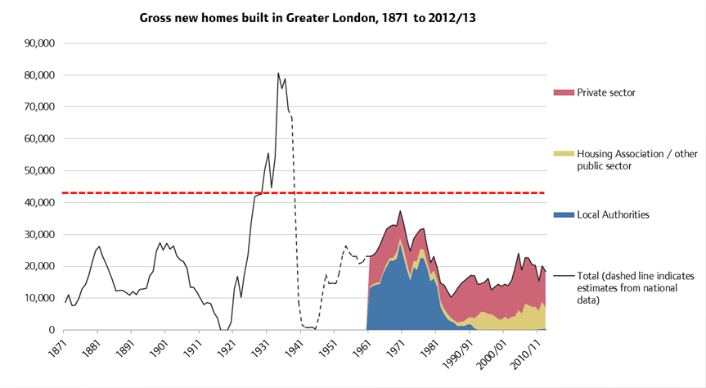
The SHMA backlog over the last 5 years represents 80,000/year which is considered unachievable.

In more detail the ambition was explained to comprise:
- At least 42,000 new homes a year
  - with 15,000 affordable & 5,000 long-term PRS
  - double intermediate by 2020 and double again by 2025
- The 2015-18 programme
  - 40 per cent low cost home ownership
  - 30 per cent at “capped” rents
  - 30 per cent at “discounted” rents
- Improved design & stock improvement
  - all homes to meet LHDG standards & bespoke PRS design
  - Retrofit every poorly insulated home by 2030
  - All council homes to meet decent homes standard by 2018

The policy ambitions are
supporting workers & meeting need
- Supporting workers
  - Improving the intermediate market
  - Supporting home ownership
  - Improving the Private Rented Sector
  - Rethinking allocations and mobility
- Meeting housing need
  - increase provision of purpose built homes for older people
  - halve the level of severe overcrowding in SR
  - no second night out and no living on the streets

The funding package of approximate figures is
- Over £1 billion to support the delivery of 42,000 affordable homes in 2015-18 (40% low cost home ownership, 30% capped rents and 30% discounted rents)
- Up to £200 million for the London Housing Bank to deliver up to 3,000 homes
- Around £145 million to improve the condition of 9,500 council-owned homes
- £120m for the Get Britain Building Fund to kick-start housing delivery on 22 sites to deliver 2,755 homes up until 2015.
- At least £750m in aggregate from the Build to Rent programme and the Help to Buy equity loans programme up until 2016.

Discussion
AB said that part of the aim is to incentivise small builders.

Duncan Bowie reinforced the encouragement to small scale builders and that this should not simply be the preserve of the top ones. Taking the lower capacity figure he was more nervous about density although in terms of deliverability 42,000 is more realistic than the targets of up to 80,000. He said that what the report does not deal with is underoccupation, housing incentives and how you control effective supply. He advocated taxation of international investors. He queried the achievability of 30% capped rents.

DB was concerned that London cannot assume self-containment and is dependent on a wider commuter catchment and dormitory area.
Keith Fletcher from BPF drew attention to the November 2012 Housing SPG and its proposals for market rental housing, (which precedes more recent demographic data from the census). The strategy also sets an annual target of 5,000 homes specifically for the private rental market, which BPF supports.

The Strategy proposes 10 housing zones in existing opportunity areas of London that would be supported with light-touch planning measures and tax incentives.

DB thought that housing allocations were work based and this could be a problem for those who are in and out of work. There is also a problem of increasing fare costs penalising those working in the capital with a long commuting journey. This would only be solved by a return to low cost fares as was the case in Victorian London.

DB also thought that the 40,000 homeless figure was too low.

AB responded briefly to some of these points in view of time constraints: The number of those in work is increasing. There were many not caught by the benefits cap. The strategy envisages the size of family housing being reduced to provide more 1 and 2 bedroom properties. The cap on borough housing was not on their policies but on their levels of investment.

The expected funding outputs are set out below:
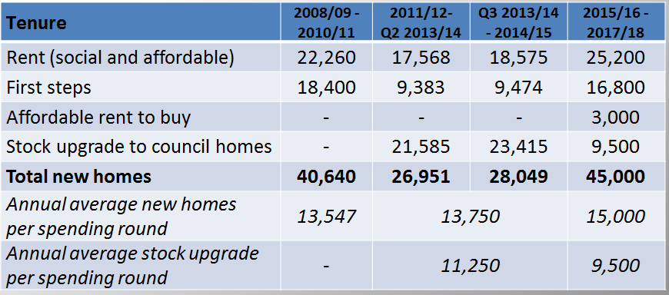

The timetable for the strategy is as follows:

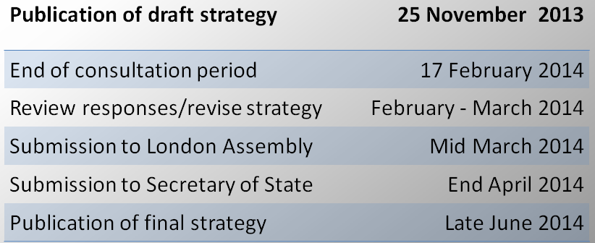

The Chairman thanked Alan Benson for his presentation.

- Emerging Issues for further alterations to the London Plan, introduced by Peter Heath GLA, with presentation material by John Lett.

Peter Heath set out the demographic issue and emerging London Plan policy responses. These are yet to be agreed by the Mayor and this is due to take place between 15th January and 9th April 2014.
It is likely this will result in adjustments rather than wholesale changes but the most significant driver comes from the 2011 census results.

London’s demographic challenge
London population 2001 (revised):7.34 million
London population 2011 (Census):8.17 million
= 83,000 pa increase
BUT
London Plan 2011 – 2031 assumes 51,000pa
AND
new GLA trend projection 2011 – 2036 suggests 76,000 pa, and over 100k in earlier years….

Emerging spatial proposals
Wider South East: GLA Act duty to inform/ Localism Act Duty to Cooperate
Olympic legacy: carrying this forward through LLDC
CAZ: review mixed use policy in light of loss of offices to residential
Opportunity/Intensification Areas: encourage higher densities
Town centres: update network and respond to multi-channel challenge: mixed use, largely residential led intensification
Industrial locations: encourage managed release of surplus land around transport nodes
Strategic Outer London Development Centres: new eg Crystal Palace, Royals, White City, Golden Mile

Emerging housing proposals: requirements
CLG currently suggests c52,000 more households pa to 2021(cf 34k)
BUT
Is this a realistic basis for planning? Outdated household formation rates; what happens if recent changes are cyclical/short term? Accept “planning for uncertainty” – central theme for FALP and LHS
New SHMA: ranges around GLA central household projection (40k); backlog of need (10 or 20 years?); other factors eg second homes? = 50-60k pa working proposition

Emerging housing proposals: supply
New NPPF compliant, needs driven SHLAA
More rigorous approach to exclusions, probabilities, phasing : challenge based: c40k pa cf 32k
‘Potential’ large sites confidential; ‘identified’ sites public
More broadly based scenario testing, including ‘need’, town centre and Opportunity Area potential
Maintain single figure borough provision targets
Handling the ‘gap’ between requirements and capacity: Opportunity Area/Town centres/Industrial release; PMM; early review

Emerging housing proposals: density
Maintain current ‘SRQ’ based approach (possibly update through full Plan review)
BUT
Flag scope for higher densities in town centres, Outer Areas, surplus industry (+PRS (Ch 2)
Recognise importance of sustaining local character in suburbs (Ch2)

Current Matrix is

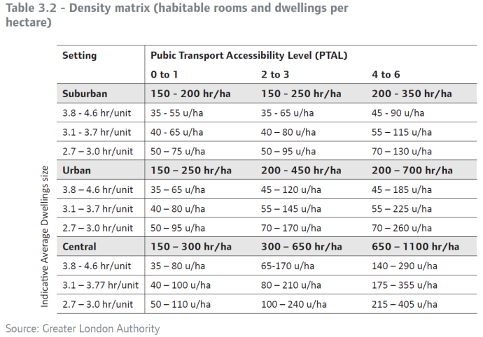

Emerging housing proposals: quality including play
Maintain current approach
Allow standards to bed down
CLG standards review: London’s distinct circumstances (NB scale of provision, densities) justifies maintaining London’s approach

Emerging housing proposals: large developments
Emphasise importance to provision and potential for large scale Private Renting Sector
Stress role of OAPFs in bringing forward capacity

Emerging housing proposals: choice
Maintain same priority for affordable family housing
Older persons special needs - significant growth: recognise distinct economics; allocate sites; mainly private, new forms of intermediate?
Student accommodation - Academic Forum: scale and distribution; dispersal; affordability; links to unis; quality; partnership working
PRS – recognise distinct economics (funding, design, amenity) in line with NPPF
Custom build, ex-forces needs - support
Emerging housing proposals: mixed communities and affordable
Update needs figures in light of new demographics
Better links with London Housing Strategy
Otherwise maintain policy

Emerging housing proposals: existing stock and future investment
Update in light of Housing Strategy
Barriers to Delivery - translating approvals to completions: distinguish build out rates; speculators; genuine barriers (planners et al)
Clarify importance of viability: S106, CIL in light of new regs/N Devon

Emerging housing proposals: social infrastructure
Flexibility to enable social infrastructure providers to ensure continued delivery (e.g.in community safety and health)
Clarify new role of public health in Boroughs and links to planning
Stronger support for free schools
Underscore playing fields need assessments

Emerging economic proposals
New employment projections (34k pa cf 33k)
New industrial, office, retail, tourism demand/supply assessments –up date policies
Significant update to town centres/retail policy
Minor update to industry
Possible updates to CAZ office policy – more protectionist?
New clustering policy notably for betting shops, possibly takeaways
Support for pubs, SMART London

Emerging proposals on climate change
New policy promoting strategic power infrastructure provision
Minor updates on flood risk, Thames Estuary 2100, Drain London
Minor updates on water management and infrastructure eg Tideway Tunnel
Updates on waste management eg reuse, relations with ROSE

Emerging proposals on transport
Highlight importance of Xrail 2 as next major infrastructure project
Possible framework for HS2 in London
Update table of infrastructure commitments to reflect greater population
Refine parking policy to make more sensitive to Outer London

Emerging proposals on places and spaces
Clarify Lifetime Neighbourhoods Policy
Expand on neighbourhood planning, including Community Rights
Clarify Designing out Crime
Update noise policy
Updates policies on POS, geology, trees, burials, World Heritage Sites, resilience to emergency, public realm management
Blue Ribbon Network: new section on Royals
Emerging proposals on implementation
New policy to support effective infrastructure development and delivery
Greater flexibility on S106 priorities

Discussion

Duncan Bowie asked when more detailed social infrastructure guidance would be given (the final forthcoming Shaping Neighbourhoods SPG, given that this was dependent on the market to deliver) and what greater flexibility is s.106 meant. He was concerned about the relationship between rising public transport costs and people’s ability to pay for affordable housing. In spite of this dispersal of London’s family housing is happening anyway with London increasingly unable to meet housing demand by self-containment.

There was a discussion about the Duty to Co-operate. Peter Heath said this was not the same as a duty to impose a solution. This however is difficult to reconcile with the growing number of development plans which are considered unsound. Genuine co-operation ought to result in negotiayed solutions between authorities. The problem is particularly acute between London and its neighbouring authorities.

There are a number of proposals for industrial land release to ease the housing pressure (figure 7.3 of the Housing SPG November 2012).

Unplanned low cost housing was also discussed. Brian Waters said that large builders had exactly the same problem as the smaller scale ones insofar as neither group would put to the market more units than people could afford to buy in order to regulate localised oversupply.

Brian Whiteley said that less waste was being generated nowadays than previously apart from paper and that the proportion of land devoted to it is less than it was.

- Minutes of the Meeting of the Forum held at on Monday 16 September at RIBA 77 Portland Place. And matters arising.

These were agreed.

- Treasurer’s report.
It was reported that subscription rates should be unchanged.
- Next Meeting.
The next meeting will be held at GLA City Hall on Monday 10th March 2014 (or if this is not possible Tuesday 11th), hosted by Colin Wilson. Agenda to be agreed.

- Review of standing items.
Lee Mallet is to edit the Yearbook with a suite on each Borough including contacts to be regularly updated on the website.
January see a regular issue of Planning in London.
7. AOB

There will be a series of RTPI articles on the future of London in January/February 2014

DR/dbm 19.12.13

