

[www.planninginlondon.com](http://www.planninginlondon.com)

**Minutes of the Meeting held on Monday 8th September 2014 at RICS HQ 12 Great George Street (Parliament Square) London SW1P 3AD between 2.30 and 5.30pm. Our host was Abdul Choudhury**

Present:

Brian Waters: Chairman

Abdul Choudhury: RICS

Andrew Rogers: ACA

Brian Whiteley: Planning Aid for London

Dan Lewis: CE Economic Policy Centre

Duncan Bowie: University of Westminster

Jonathan Manns: Colliers/RTPI London

Judith Ryser: Isocarp/Ugb/Cityscope Europe

Malcolm Hockaday: Lichfields

Marnix Elsenaar: Addleshaw Goddard

Michael Bach: London Forum

Michael Coupe: London Society and Coupe Planning

Michael Edwards: UCL

Peter Eversden: London Forum (Ch)

Tom Ball: London Forum

Drummond Robson: Honorary Secretary and Robson Planning

1. **Introductions and Apologies**.

Apologies were received from Asha Saroy, Bob Dolata, David Bradley, Ghislane Trehearne, Ron Heath, Tim Wacher and Yasminah Beebejaun.

1. **A Tribute to Sir Peter Hall who died on July 30 2014 by his close colleague Michael Edwards.**

Michael recalled from undergraduate days as an economics student at Oxford.his introduction Peter Hall giving a talk about Fred Pooley’s proposals for a new City in South Bucks including a monorail network giving immediate access to the countryside. He was a “railway buff”.



Pooleyville 1966

Although Pooleyville never took off it inspired Michael to study planning following “this remarkable man” following his example as a passionate planner as a technical skill to provide practical and thoughtful interventions. Peter was an excellent teacher who believed in the need for education to be real. “I miss him terribly” commented Michael.

He intervened constructively in many ways in London such as the alternatives proposed in London 2000, the Examination in Public into the London Plan, and in regional Planning for the South East. He believed in the City as something to be understood, He advised Michael Heseltine on Enterprise Zones, and was part of Richard Rogers’ Task Force until disagreeing with the implications of densification. In the late 1990s he had this crazy idea of linking bits of London railways which resulted in a report jointly with Michael and Drummond Robson to the London Development Partnership under Eric Sorenson to prepare the ground for the new Mayor of the GLA. The central proposal was the Orbital Railway. Though given short shrift following the report the idea was picked up again following presentations to the TCPA by Peter and Drummond and adopted by the Deputy Mayor Nicky Gavron. It has been built and is very successful resulting in gentrification of the areas through which it goes.

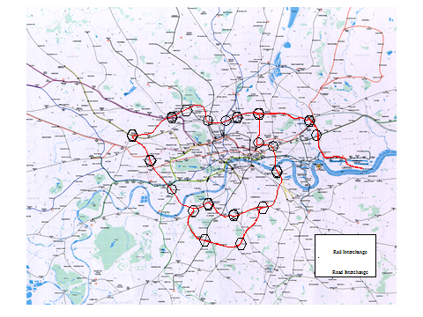

A memorial is to be held on 22nd October “Remembering Peter Hall” at the Royal Geographical Society in Kensington.

Drummond Robson picked up the final extract from Simon Wicks’ article in The Planner for September 2014 “The full title of that final chapter in Kaleidoscope City [Jonathan Manns] is “The Strange Death of British Planning: And How to bring about A Miraculous Revival”. “We need, Hall stressed not less planning but more; positive planning by well equipped multi-skilled teams making masterplans, which are then implemented by private developers or co-operatives”. We knew how once, We can do it again”. This compelling formula is one that DR has sought to follow for much of his career, both working at Farrells and subsequently, often in spite of the planning system itself.

1. DISCUSSION TOPICS
2. **Infrastructure and Planning** . The topic was introduced by Dan Lewis, Energy Policy Adviser to the [Institute of Directors](http://www.iod.com/) (IoD). He is also Chief Executive of the [Economic Policy Centre](http://www.economicpolicycentre.com/) – the think tank hub of the UK economics community and Chief Executive of [Future Energy Strategies](http://www.future-es.com/). (He spoke in a personal capacity).

Dan Lewis explained that IoD has 35,000 members and provided it is pro business he is able to pursue his own agenda. Outreach & meetings were a big part of his IoD work;

Working part-time for IoD since 2011, he has been working on Economic, Energy, Geospatial Data, Research & Media, Space Economy: UK Spaceplane Regulatory Workshop Committee

Energy Policy and Events. The Infrastructure Challenge: *How much, for whom, at what cost and when?*

IoD has been conducting its own reviews Defining & Scoping Infrastructure

* + Defining: 1) Social (Hospitals, Schools) & 2) UK National Infrastructure Plan: Roads, railways, Ports, Energy, Telecoms, Flood Defences, Waste, Intellectual Capital & Water (also local amenities & Airports)
  + Spending? £45 bn in 2013 or £375 bn by 2020 (Questionable)
  + Focus? £340 bn on Energy (£215bn or ¾) & Transport (Value for Money?)
  + Private Sector Delivery? 85%
  + Who owns it? 60% Private Sector (Armitt Review)
  + Infrastructure spend – N.B. logarithmic scale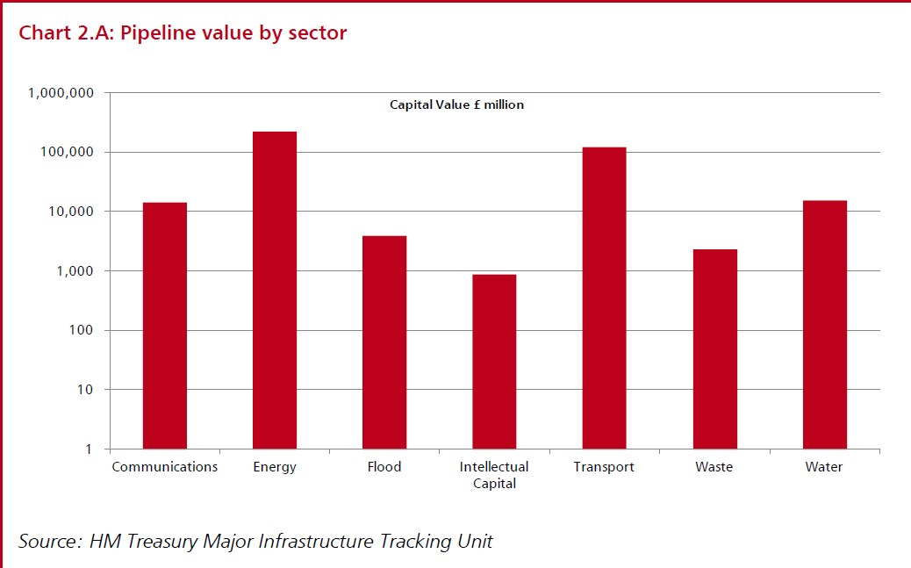

UK Infrastructure “Challenges” # 1

* + A poor world ranking: 28/144 versus 8/144 for economic competitiveness (WEF)
  + Fast growing population: 70m by 2030
  + Govt. stimuli – time lag 6-24 months, tendering, procurement, planning, EIAs
  + Tracking opportunity costs – hard to measure silent & invisible victims
  + Being realistic about the multiplier effect - buying, hiring, producing and unsustainable lumpy distribution of capital expenditure

UK Infrastructure “Challenges” # 2

* + Future & whole life costs: too much emphasis on value added by construction – not enough on cost-generating post construction
  + Planning: favours “No” - e.g. shale – risk capital in short supply
  + Political risk – bigger the project, more politically vulnerable, raising cost of capital
  + There is not enough money – £200 bn? Utilities are broke
  + Consumers, Taxpayers & SWFs – far from willing to foot the costs – e.g. Offshore Wind, Hinkley C, Smart Meters & New Hub Airport Connectivity

Shale: what’s the hold-up? Regulations. To complete the steps of the Department of Energy and Climate Change steps takes 6-8 years and is very uncompetitive. The same process in Texas takes up to 2 weeks! The effect is that lenders are not interested in investing in the UK.

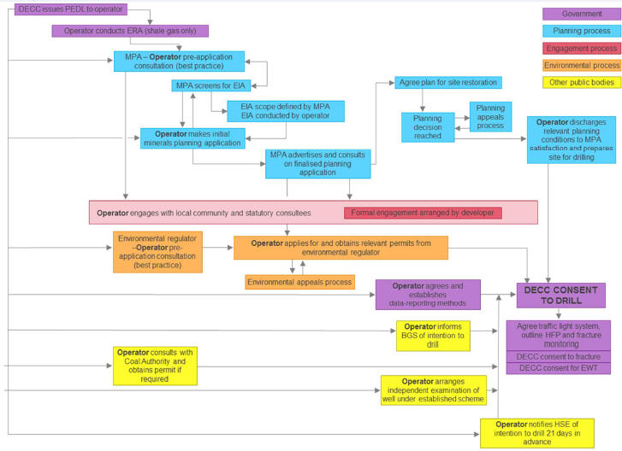

Infrastructure Policy Environment

* + *A wish list of construction, engineering and Blue Chip Consultancy Industries*
  + Mantra of spending is always good and adds value

Infrastructure Policy – A new Approach

* + From spending driven to full spectrum CBA
  + Speed up & reduce cost of planning
  + A shift in management – public to private
  + Increase private ownership
  + Enhanced open data drive – e.g. data on roads, flood plains data
  + Infrastructure Policy – A new opportunity
  + Capex smooth or lumpy?
  + Create additional consumer choice?
  + Crowd out existing infrastructure?
  + Promote capital deepening?
  + An additional asset?
  + What are the on-costs?
  + IoD Infrastructure Value Index in development
  + 3 Publications in Prospect
  + September: *Infrastructure Financing*
  + TBC: *Annual IoD Infrastructure Report*
  + October/November: *Airports: Evolutionary Optimal Decision Time*

Later

*Broadband – faster, cheaper, how?*

Trains

Housing?

* Infrastructure Finance in prolonged period of Austerity
  + PFI to PF2 – approx 8%
  + Electricity Market Reform – 10-12%
  + Regulated Asset Base – 3.8 – 4.9%
  + 30 Year Gilt Yield – 3.02%
  + To watch: Network Rail debt piling up
* Airports – South-East Expansion
* Topical issues: Airports, Spaceports, Scotland, National Infrastructure Commission?
  + Review in progress of IoD policy
  + Will not be bound by shortlist, SIFT criteria or timeframes of the Davies Commission
  + Will ask different questions, model different scenarios
  + And be conscious to cost of public purse, consumer choice, competition, and range of existing and future business models
  + ITE – Piraeus Harbour of 21st Century with BoJo as Pericles?
  + Or a “Megaproject” (Prof. Bent Flyvbjerg) See [Megaprojects and risk – An anatomy of ambition](http://www.amazon.com/Megaprojects-Risk-An-Anatomy-Ambition/dp/0521009464/ref=sr_1_1?ie=UTF8&qid=1370443959&sr=8-1&keywords=Megaprojects+and+Risk+%E2%80%93+An+Anatomy+of+Ambition) Are we destined for repetition of Megaproject’s *Iron Law:* Over budget, over time, over and over again?
* Spaceports
  + Submitted to Review – findings announced Farnborough
  + *Shortlist: Newquay, Llanbedr and 6 in Scotland*
  + Stornoway, Lossiemouth, Kinloss, Leuchars, Campbelltown, and Glasgow Prestwick
* Vehicles in Prospect – UK



* Later? Masten Space Systems, Armadillo Aerospace, Blue Origin
* Not about who launches first
* But who launches how often, from where and at what price
* Small satellite launch from UK?

 

* Air launched proposals
* From 2020s possible
* Research going into vertical launch from UK
* < 500 kg
* Requires different kind of spaceport
* An Independent Scotland ?
  + Major risk of stranded infrastructure assets
  + Will rUK pay for Scotland’s oil and subsidize their renewables and 100% 2020 target not possible without exports to England?
  + Transmission upgrades on hold – size of Scottish domestic market and tax base not enough to meet the cost
* An Independent Infrastructure Commission?
  + Could create a tax-funded body that always argues for tax-funded infrastructure
  + But clearly a need to develop a more systemic approach to infrastructure
  + Which Olympic Delivery Authority did – albeit under unmoveable time constraint

Opening discussion of this wide ranging subject Peter Eversden queried the value of the Supersewer (Thames Tideway Tunnel). Dan Lewis confirmed there were other detractors such as Ian Byatt th some time chairman of Ofwat.A decision on the sewer is due this week. Dan Lewis queried the value of forecasting 50 years ahead and suggested “Bazelgette 2” might be more appropriate.

Duncan Bowie queried the principle of starting with funding and determining what to deliver derived from that, preferring the planning principle of considering alternative scenarios and how to deliver them. Dan Lewis was concerned that this leads to speculative risk and did not see the relationship between energy and residential growth or employment. Picking up a question from Brian Waters as to why HS2 goes through Tory marginal seats he cited HS2 as benefitting London far more than the regions according to KPMG.

Tom Ball was also opposed to the money first plan afterwards principle.

Michael Bach was concerned that we are becoming increasingly ideological rather than rational in our infrastructure planning. He suggested we should ask who gains, (those with the advantages). Often schemes contrive to keep the cost off the books, rather like Starbucks not paying tax.

Dan Lewis said that regeneration would be done by the Australians if they were allowed to take their profits home.

He considered that Maplin may have been the airport answer if it had been carried out at the time but that its time had passed. In terms of spending priorities he thought a review of Green Belt policy is needed. Brian Whiteley queried how it would be possible to deal with housing growth without a regional plan given the lack of an interface between London and the Shire Counties. He thought the French model of using infrastructure to fuel housing growth was desirable.

Mike Coupe voiced his opposition to the Barker nostrum of weakening the planning system to enable more housing to be built, which had not happened. Developers want to put housing on the market only when there is a profit. What is needed is more public housing.

Michael Edwards was concerned about who pays and who benefits. Groningen in The Netherlands came out as the most wealthy place in the country because that was where the oil was even though it did not benefit any of the locals.

The Chairman thanked Dan Lewis for his thought provoking presentation and suggested that he may wish to return next year once his ideas on airports policy had evolved further.

1. DCLG's current consultation: Technical consultation on planning and its substantial proposed further reforms of the system. Marnix Elsenaar of Addleshaw Goddard has been invited to open the discussion. See: <https://www.gov.uk/government/uploads/system/uploads/attachment_data/file/339528/Technical_consultation_on_planning.pdf>

Marnix Elsenaar approached the topic with a “forward looking manifesto” as a way of provoking discussion. He put forward six propositions timed to coincide with the Conference season and aimed at housebuilders, local government etc.The propositions are deliberately somewhat extreme.

1. A study to identify the purpose of the green belt, th different types of it and where it can be built on.
2. A National Economic Plan (or strategies) – there are national policy statements and development control orders but these have not helped determine future airports policy or a basis for HS2 and so a proper economic plan is needed.
3. 5 London Boroughs. Many of the functions of the 33 boroughs are simple duplications. A reduction to 5 would be more efficient, concentrate expertise and result in the need for fewer external consultants. The duty to co-operate should be more effectively applied.
4. Regional Housing Targets. The removal of RSSs has been harmful, we have NPPF/local tensions and no clear regional basis for housing targets or regional planning policy. The NPPF offered a chink in the armour but was shot by Nick Bowles.
5. Derelict Land Giveaways. Unused derelict land produce no revenue or development. In view of this sites should be given away with planning permission, setting a time limit for development to take place and relax rules governing “best consideration”
6. Public Land for Housing. There is at present too much unused public land which adds to land scarcity, so its land price should be reduced and local government be given targets with sanctions if these are not met. Overage payments would provide incentives.

Marnix Elsenaar cited The Wolfson Prize which was won by URBED. David Rudlin argues for the near-doubling of existing large towns in line with garden city principles, to provide 86,000 new homes for 150,000 people built over 30-35 years. The entry imagines a fictional town called Uxcester to develop the concept, and applies that concept to Oxford (2011 population: 150,000) as a case study, showing how Oxford could rival the strategy adopted by Cambridge for growth and expansion. David argues that there may be as many as 40 cities in England that could be doubled in size in this way, such as York, Norwich, Stafford and Cheltenham. 20% of new homes would be affordable housing.

This proposition implies a Green Belt Review and town expansions rather than new towns.

The principle of Localism is constantly undermined by top down policies in departmental consultations from CLG.

The Chairman commented that the driver of unaffordability goes back to value of land for housing and hope values allowing or preventing its use. The discussion concentrated on the Consultation propositions.

Brian Waters welcomed combining A1 and A2 as an extension of permitted rights. The current freedom for three years should be modified to require completion in a specified period.

Peter Eversden suggested that all proven exemptions should be removed.

Michael Bach opined that if people were given a fee transfer of use from one to another that use would disappear as the higher value use took over. This is supported by the RBK and C exemptions. Marnix Elsenaar responded by suggesting this could be overcome by the requirement for prior approval.

It was replied that prior notification within a flood zone it would automatically be refused thereby making prior approval irrelevant.

Michael Bach was concerned at the risk of losing social and community uses with no reality check, and their absence would make communities very boring with simply a mixture of housing, restaurants and sui generis uses.

Brian Waters wondered whether the merging of A1 and A2 would help in secondary High Street locations. Policy rations these to prevent for example too many cafes. The idea would be to try to free these up with any A use frontages.

Michael Bach responded by saying that in the case of A2 and A3 uses would displace useful shops. Where there is a market social uses are displaced. For example charity shops can pay morefor their units.

Duncan Bowie was concerned that if local authorities’ ability to set land uses was removed impacts could not be assessed. It should be the case that uses should be assessed together with their ability to provide adequate supporting infrastructure.

Brian Waters thought some of the proposed reforms would be unnecessary if Local development Orders were imposed.

EIA Urban Infrastructure thresholds should be raised from the artificially low area of 0.5 ha which requires large expensive reports which are difficult to assess and penalises small and medium sized development companies in particular.

The consultation exercise was more generally criticised for being introduced against the ideological background of the need to increase housing numbers and showing something was being done. It was promoted more by the Treasury than DCLG.

1. Discussion of the Impact of Tall Buildings on the Character of Cities and the GLAs recent Shaping Neighbourhoods Character and Context SPG was postponed following late withdrawal on main speaker and no response from GLA. <https://www.london.gov.uk/priorities/planning/publications/shaping-neighbourhoods-character-and-context>
2. Minutes of the Meeting held on Monday 9th June 2014 at Colliers International 50 George Street London W1U 7G and matters arising.

These were accepted.

1. Treasurer’s report.

Not available

1. Next Meeting.

The next meeting is proposed to be held at the British Property Federation 5th Floor   
St Albans House, 57-59 Haymarket, London SW1Y 4QX on Thursday 11th December 2014. The agenda has yet to be formulated.

1. Review of standing items.

None

1. AOB

None.